# Talking Ham Logbook

## Talking HAM Goals and Objectives

The main goals for the project is to design and build a cost-effective High Power, High Frequency RF Amplifier, which could be built by an experienced home constructor.

The amplifier design should be scalable so the power of the system should be able to be scaled up to 400W and beyond.

It should be able to amplify a wide range of RF signals.

The system should be cost-effective system meaning the cost should be around £4,000.

One of the most challenging environments for RF propagation losses of waves is in forested environments, so a second objective would be an investigation into this, as this linear amplifier may be used in these situations.

# Requirements

These goals were then uses to create the requirements shown in Figure 1, this shows the requirements which were generated from the goals. In general these requirements are not too serve and are easily manageable.

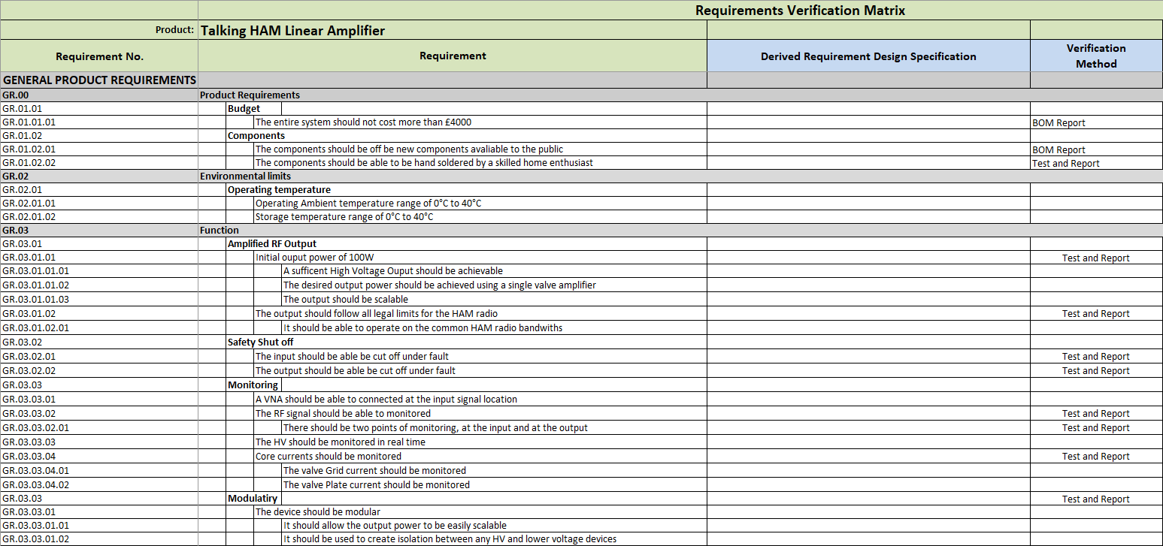

Figure 1:- Requirements for the Amplifier

# Research

## Project Context

### Classes of amplifiers

There is a range of different classes of amplifiers, but the most commonly used ones for audio amplifiers are A, B, C, AB and the main difference between the types are in the conduction angles. Examples of the most common classes are shown in Figure 2.

* Class A will amplify the entire 360° of the signals, through one device. This is the least efficient amplifier.
* Class B and AB both conduct the full wave through two 180° samples. The difference between A and AB is that AB has biasing, which deal with the unstable cross over point of a class B. This is the significantly more efficient than a class A amplifier.
* Class C amplifies less than 180°, meaning that Class C has a higher distortion effect than the other classes mentioned. This is the most efficient version of these four amplifiers.

For RF amplification a Class A is required for minimal distortion.

|  |  |
| --- | --- |
| Class A CLASS A Amplifier | Class B CLASS B Amplifier |
| Class AB CLASS AB Amplifier | Class C CLASS C Amplifier |

Figure 2:- Class A, B, AB, C Amplifier Examples [1]

### Why are valves being used over semiconductors?

In low power transistors are the better choice, as they have a inherent ability to deal with low voltage, high current situations, which valves just cannot compete with.

In high-power system, the advantages semiconductors had at lower voltages are not present, and valve takes over. Because valves are inherently suitable for a HV circuits, meaning in higher power systems it leans in favour of valves.

The cost also affects it, in lower power systems as a valves are more expensive than solid-state devices, but as the power goes up, the cost of the solid-state devices design goes up significantly compared to the valve.

The graph shown in Figure 3 i) shows this, although from 1998, similar arrangements still apply today.

|  |  |
| --- | --- |
| i) | ii) |

Figure 3:- Normalized cost vs power of valve vs Solid-State [2]

Frequency is another factor as valves compared to a solid-state device power output significantly higher, especially at higher frequencies. Figure 3 ii) shows that the power of large vacuum devices on average are higher than solid-state devices, with some exceptions, but this is not useful foe most amplifiers people deal with as they are normally low power devices, but in higher power devices at higher frequencies, the valves stand out.

### What is a Linear Amplifier and Why is it needed?

A Linear Amplifier can be defined as an “active electronic circuit that creates an output wave form that is an accurate reproduction of the input wave form that increases and decreases in direct proportions”. [3] This means the output is just the input but 180° out of phase with a larger amplitude. This means if a 1 watt 1 kHz sine wave signal is passed in with a power gain of 100, then a 100 watt 1 kHz sine wave would be passed out. Linear Amplifiers can be Class A amplifiers as they conduct constantly or Class B if they are configured to work in Push Pull configurations, but because Class C is not linear it cannot be used in a linear amplifier.

A Linear Amplifier is needed, as the output of a Transceiver is often not as powerful as desired/needed for its intended purpose. For example an output of a transceiver could be 10-100W, but an output power of 40-400W could be needed or a 1.5 kW or higher might be even required. In order to do this, a linear amplifier is required in order to boost the power of the RF signal up to the desired transmitting power.

This is important as a more powerful RF signal is often required or desired depending on different use cases. Designing a Transceiver which outputs a very high power straight away would produce a large amount of noise, which a linear amplifier can help with, as it can filter both the input and output to reduce the noise compared to a single stage RF Transceiver.

### Behaviour of Waves

#### What is Propagation?

Propagation is how wave is travelled from one point to another through a medium, e.g. an atmosphere, a vacuum or water [4]. Since RF signals are electromagnetic waves, they exhibit many different behaviours like reflection, refraction, diffraction, absorption, polarisation and scattering which all effect how it propagates.

#### What is a normal?

A normal is an imaginary line perpendicular to a line or surface. Figure 4 is an example and Figure 5 is one on a curved surface.

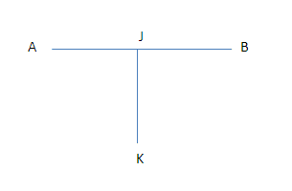

Figure 4:- Normal to a line [5]

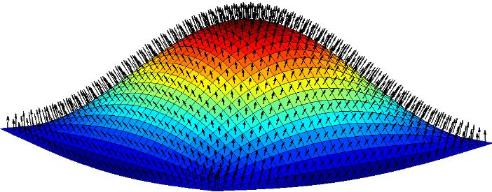

Figure 5:- Range of different Normals on a curved Surface [6]

#### What is Reflection?

A wave can be reflected at certain boundaries. Reflection is where a wave hits off an object and then bounces off. Figure 6 shows this reflection off a boundary, and in it an angle hitting the reflector is the same out, around the normal.

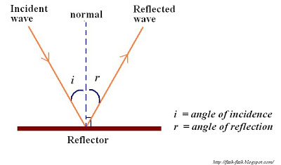

Figure 6:- Wave Reflection off a Boundary [7]

There are two main types of reflection, these are fixed and free end reflection, in fixed end reflection, when the wave hits the boundary the reflected wave is inverted, shown in Figure 7. In free end reflection, the reflected wave is the same with no inversion, shown in Figure 8 [8] [9].

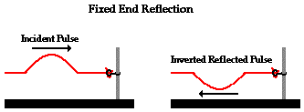

Figure 7:- Fixed End Reflection

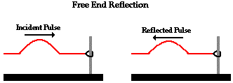

Figure 8:- Free End Reflection [10]

#### What is Refraction?

Refraction is caused when light changes speed changes, if its slowing down then it bends towards the normal, if speeding up away. An example is shown in Figure 9 where it’s slowing down and thus bending toward the normal. How much it bends depends on the speed change and is governed by Snells law shown in Equation 1, which is used to calculate the amount of refraction. Several materials are shown in Figure 10 for this. Figure 11 shows both light refracting twice, once slowing down and another speeding up.

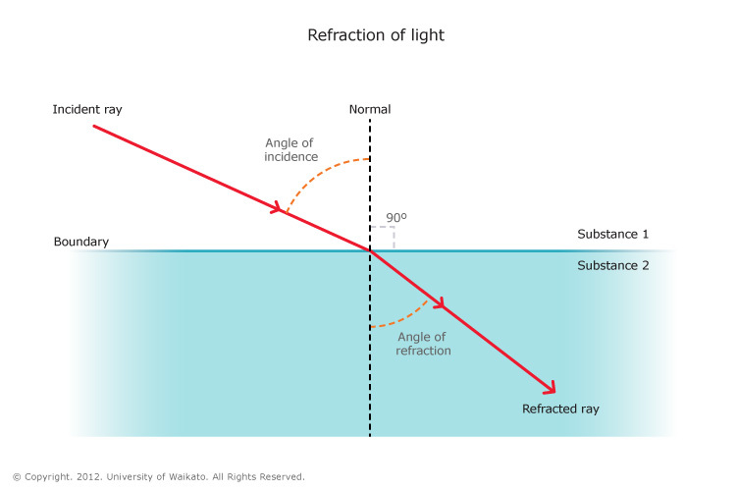

Figure 9:- Refraction of Light [11]

$$\frac{c_{i}}{c_{r}}=\frac{n_{r}}{n_{i}}=\frac{sin\left(θ_{i}\right)}{\sin\left(θ_{r}\right)} \\ where: \\ c_{i}=\begin{matrix}is the speed of light in \\ the incedence material \end{matrix} \\ c_{r}=\begin{matrix}is the speed of light in \\ the refracted material \end{matrix} \\ n_{i}=\begin{matrix}is the reactive index in \\ the incedence material \end{matrix} \\ n_{r}=\begin{matrix}is the reactive index in \\ the refracted material \end{matrix} \\ θ_{i}=is the angle of incidence \\ θ_{r}=is the angle of refraction$$

Equation 1:- Snells Law [12]

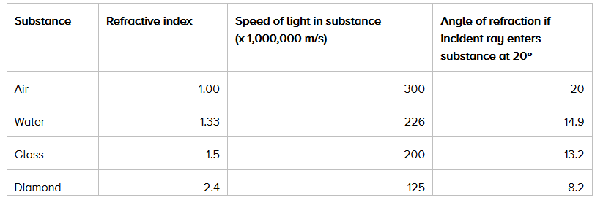

Figure 10:- Range of materials for light to refract through.

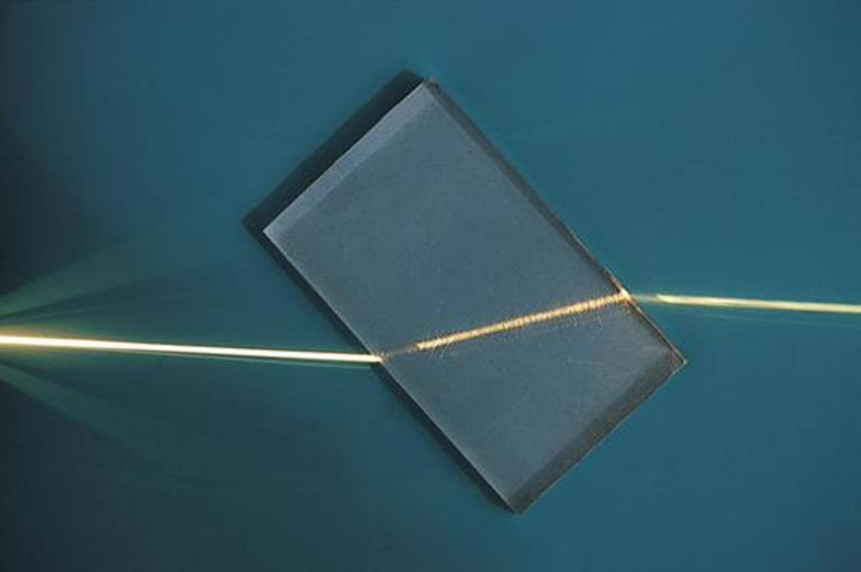

Figure 11:- Light Passing through a glass slab [13].

##### What is the Critical Angle?

As the light approaches a boundary where the light speeds up, if the angle too extreme then it approaches the critical angle, where the angle of refraction equals 90° as shown in Figure 12. After this total internal reflection occurs as shown in Figure 13. The Critical angle can be found with Equation 2.

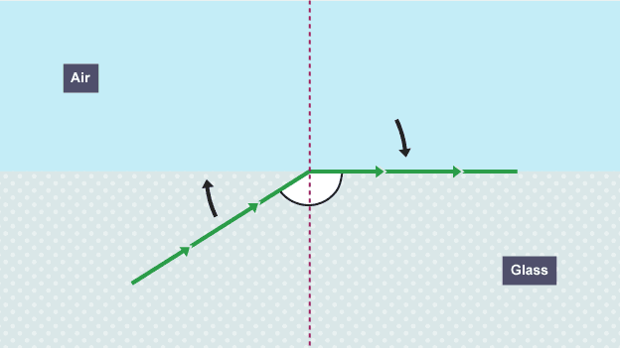

Figure 12:- Critical angle [14]

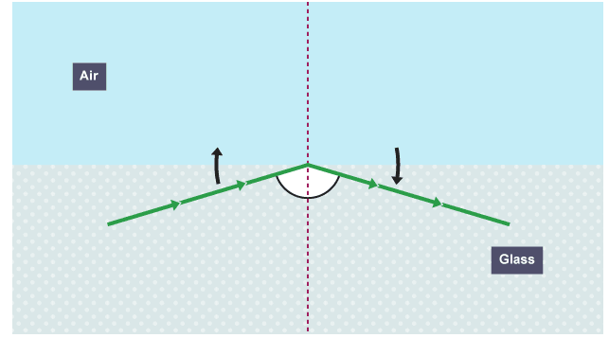

Figure 13:- Total Internal Reflection

$$\frac{n_{r}}{n_{i}}=\frac{sin\left(θ_{i}\right)}{\sin\left(θ_{r}\right)} \\ \frac{n_{r}}{n_{i}}=\frac{sin\left(θ_{c}\right)}{\sin\left(90\right)} \\ sim\left(θ_{c}\right)=\frac{n_{r}}{n_{i}} \\ where: \\ θ_{c}=the critical angle$$

Equation 2:- Critical Angle Equation

#### What is Diffraction?

Diffraction is how waves separate after passing an object and obstacles. How much it diffracts depends on wavelength and gap width. For a gaps close to the wavelength the signal diffracts more, shown in Figure 14 a). Through gaps much wider than the wavelength, the signal to diffracts less, shown in Figure 14 b). With the same fixed obstacle in the way, a waves with longer wavelengths diffracts more than waves, shown in Figure 14 c). The frequency and wavelength are related using the Equation 3, meaning lower frequencies have a much increased ability to diffract compared to a higher frequency.

|  |  |
| --- | --- |
| 1. Wave passing through gap close to the wavelength. | 1. Wave passing through gap larger than to the wavelength. |
| 1. The effect of wavelength on diffraction. | |

Figure 14:- Diffraction based on different gapes and obstacles [15]

$$V=λf \\ where: \\ V=speed of the wave \left(ms^{-1}\right) \\ λ=the wavelenth of the wave \left(m\right) \\ f=frequency of the wave (Hz)$$

Equation 3:- Wave Speed Equation [18]

### How does a valve work

#### Thermionic Emission

Metal are electrically conductive because some electrons become dislodged and free to move in the metal, the number of missing electrons is the number around the atoms so the material is stable. To make the electrons free they need energy to do this one method used is to heat the metal to allowing electrons to become free as shown in Figure 15.

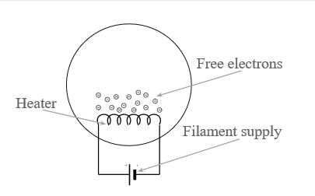

Figure 15:- Thermionic Emission

#### The valve itself

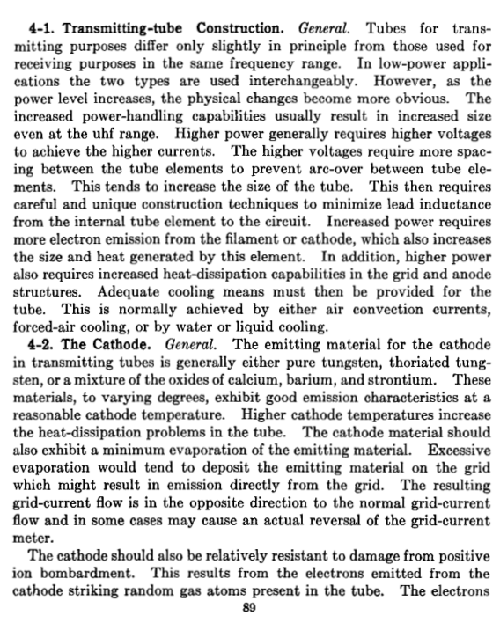

Figure 16:- Radio Transmitters PG 89

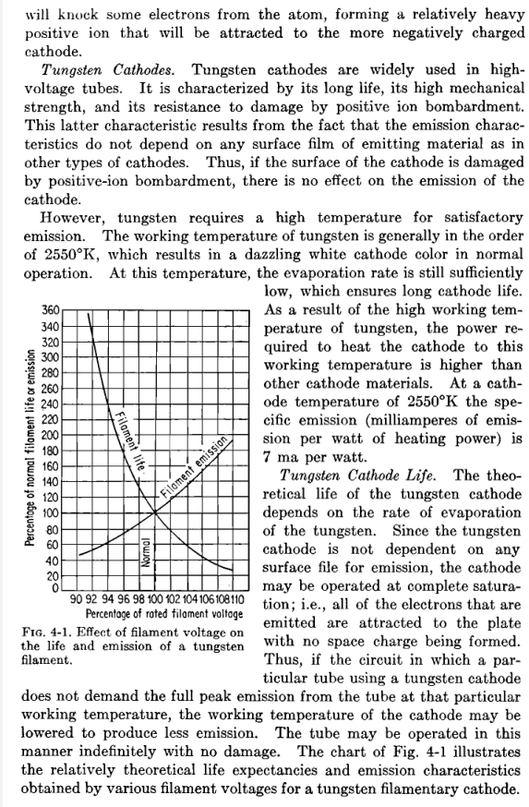

Figure 17:- Radio Transmitters PG 90

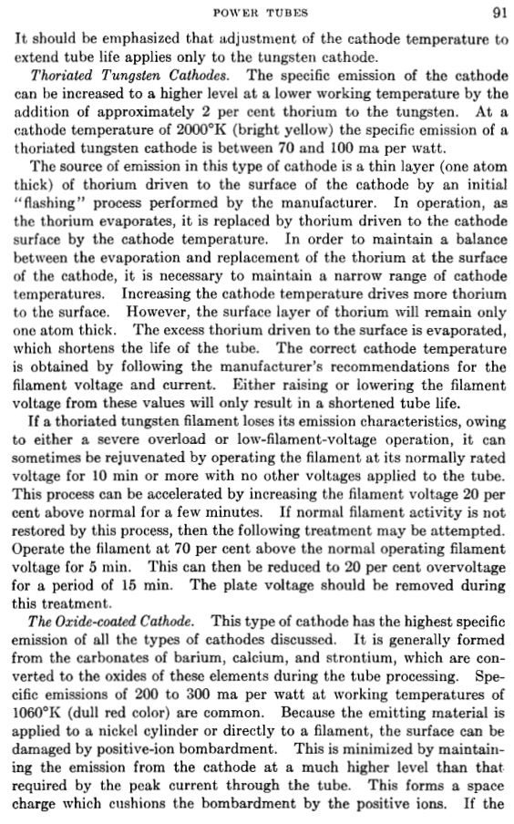

Figure 18:- Radio Transmitters PG 91

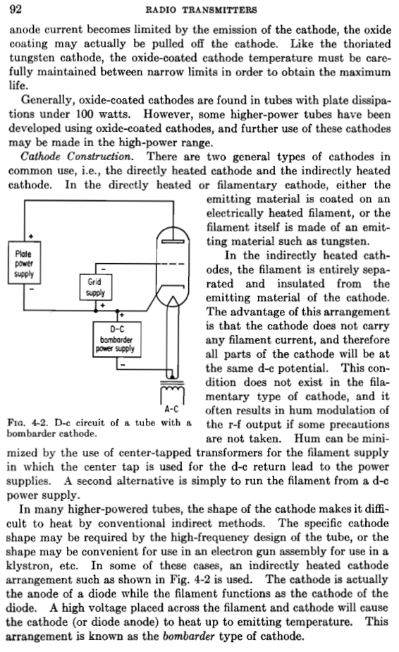

Figure 19:- Radio Transmitters PG 92

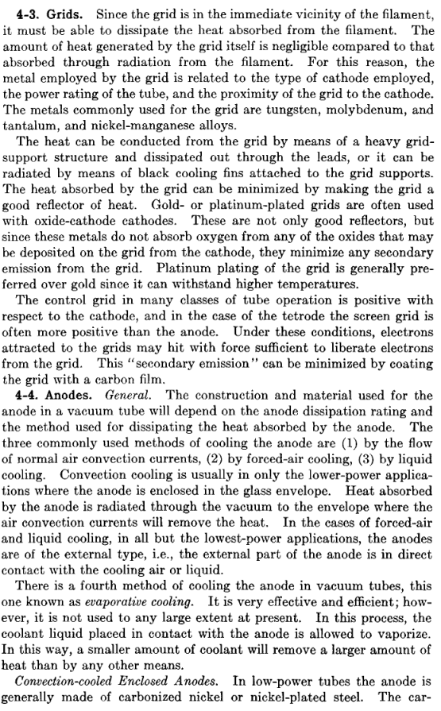

Figure 20:- Radio Transmitters PG 93

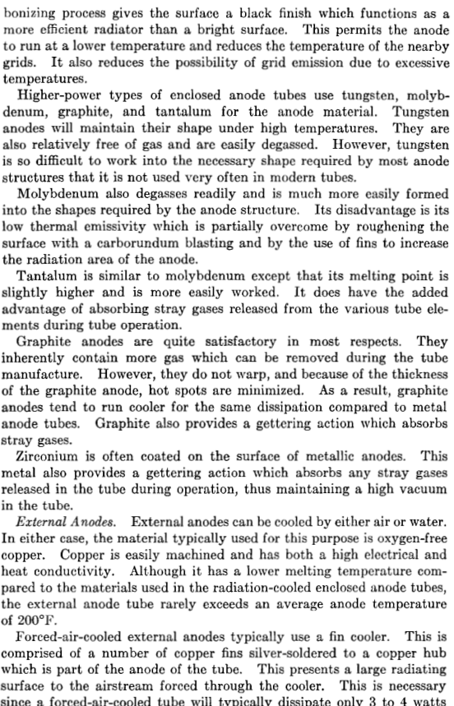

Figure 21:- Radio Transmitters PG 94

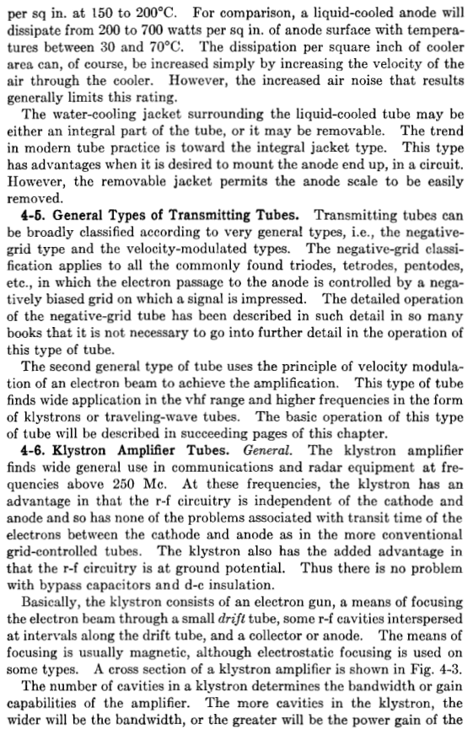

Figure 22:- Radio Transmitters PG 95 [16]

### What frequencies are being used

There are several different bands to be targeted and may be used. At the moment only a handful will actually be targeted, but the High frequency bands are as follows

|  |  |  |
| --- | --- | --- |
| Wavelength | Lowest Frequency (MHz) | Highest Frequency (MHz) |
| 80m | 3.5 | 3.8 |
| 60m | 5 | 5 |
| 40m | 70 | 70.2 |
| 30m | 10.1 | 10.15 |
| 20m | 14 | 14.35 |
| 17m | 18.068 | 18.168 |
| 15m | 21 | 21.45 |
| 12m | 24.89 | 24.99 |
| 10m | 28 | 29.7 |

Figure 23:- HAM Frequency Bands [17]

### How will this be done

A custom PCB will be designed which will then be built up in order to create this RF linear amplifier, this will follow a standard design procedure, including looking at any open source/available designs of pre-existing valve based amplifiers, for example the KW600 [18] and a modified KW1000 [19] which is are amplifiers with many benefits, these designs will then be modified and modernised, to replace components no longer made, change to better components if they now exist and change methods of doing certain things, e.g. current measurement methods using ICs. There will also an update using an MCU to control the system rather than through switches, meaning switches will be changes to multiple relays or MOSFETs instead to automate control.

### Who makes valves?

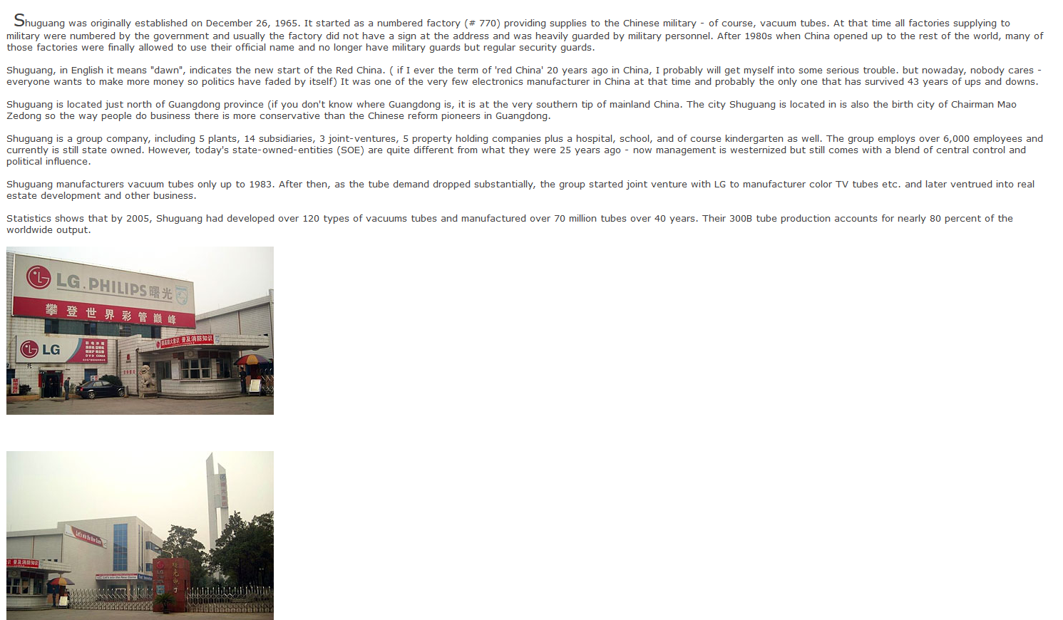

Figure 24:- Shuguang information [20].

### What is SWR

Figure 25:- SWR Explained, A Radio Amateur's Guid to Electromagnetic Waves, Transmission Lines and VSWR PG 15 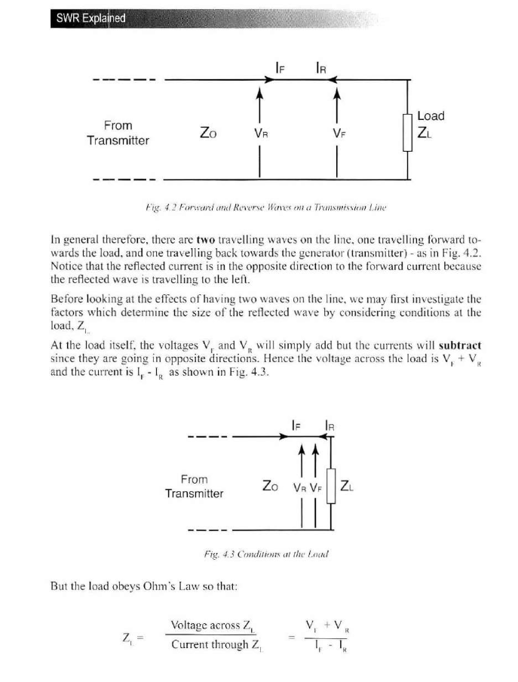

Figure 26:- SWR Explained, A Radio Amateur's Guid to Electromagnetic Waves, Transmission Lines and VSWR PG 16



Figure 27:- SWR Explained, A Radio Amateur's Guid to Electromagnetic Waves, Transmission Lines and VSWR PG 17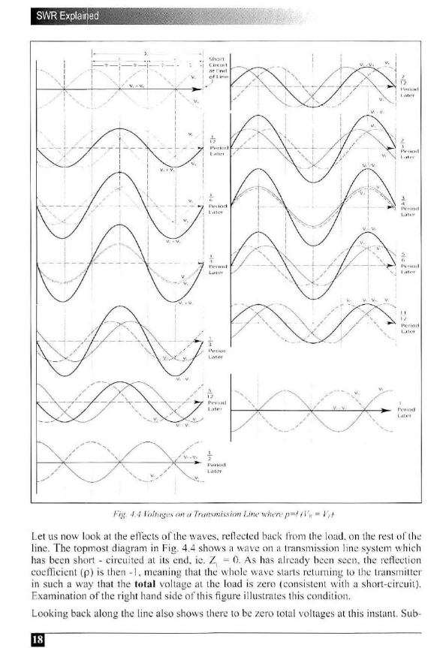

Figure 28:- SWR Explained, A Radio Amateur's Guid to Electromagnetic Waves, Transmission Lines and VSWR PG 18 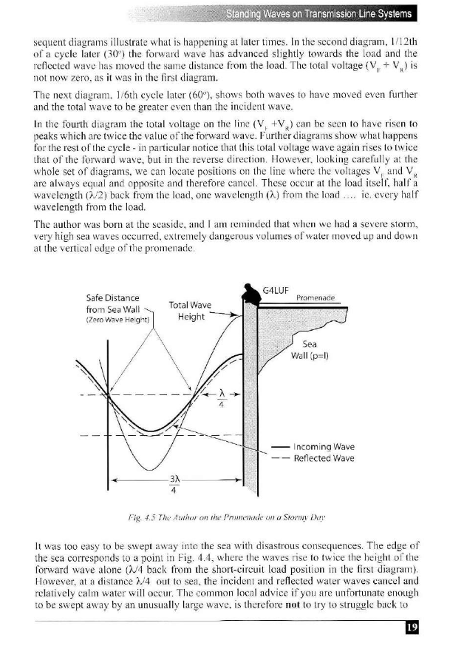

Figure 29:- SWR Explained, A Radio Amateur's Guid to Electromagnetic Waves, Transmission Lines and VSWR PG 19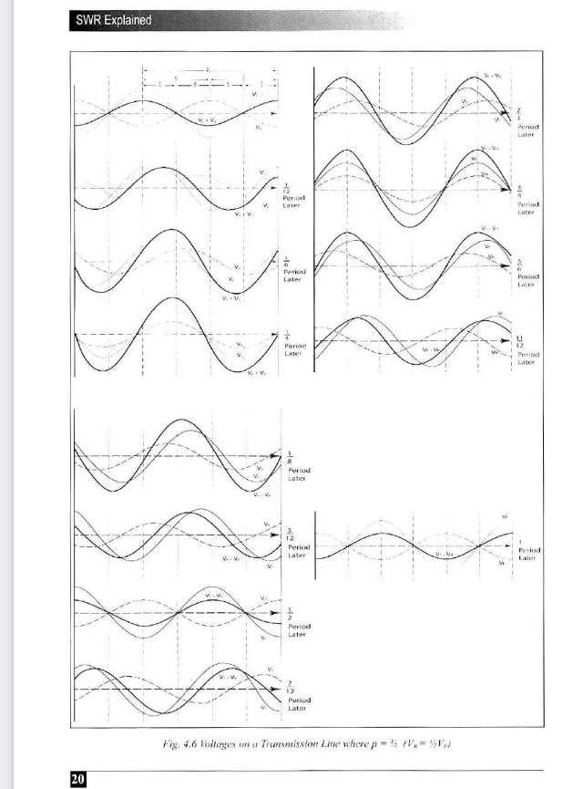

Figure 30:- SWR Explained, A Radio Amateur's Guid to Electromagnetic Waves, Transmission Lines and VSWR PG 20 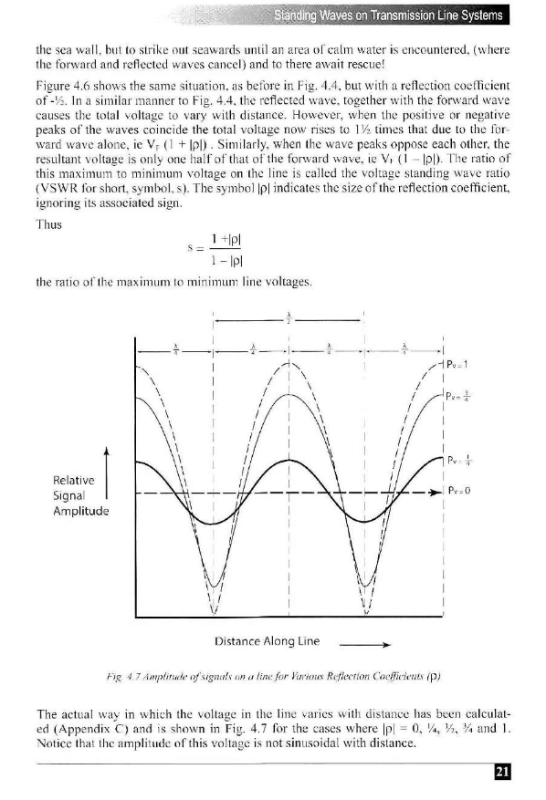

Figure 31:- SWR Explained, A Radio Amateur's Guid to Electromagnetic Waves, Transmission Lines and VSWR PG 21 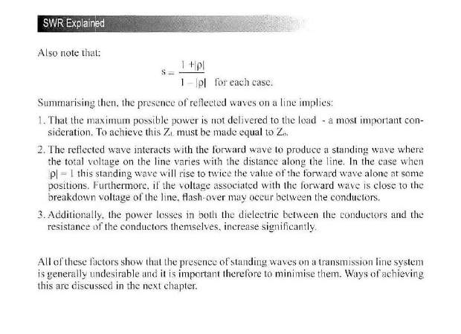

Figure 32:- SWR Explained, A Radio Amateur's Guid to Electromagnetic Waves, Transmission Lines and VSWR PG 22 [21].

### What is an ATU

SWR causes increased transmission power loss, and its reflected power can damage the amplifier. The most common way of reducing SWR in RF devices is an Antenna Tunning Unit (ATU), also known as an Antenna Tuner. These match the transmitter and Antenna impedance minimising SWR. One of the most common ATU design is shown in Figure 33 this operates by varying the capacitance and inductance which in turn changes the overall impedance to match the antennas in turn, minimising ρ, in turn minimising SWR significantly [22] [23].

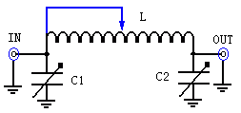

Figure 33:- Basic ATU diagram [38]

## System Architecture

There are 2 possible different possible overall system architecture of the system the difference between the two is rather simple, as one will run entirely off a Raspberry pi and the other is split between a Raspberry pi and an Arduino Due the advantage and disadvantages between the 2 are shown in

|  |  |
| --- | --- |
| Arduino Due + Raspberry Pi | Raspberry Pi |
| More Expensive | Cheaper |
| More devices to programme | One device to programme |
| Two devices to control | One device control |
| Backup MCU to increase safety | One device to fail to cause issues |
| Command Translation required | No command translation required |
| Separated computing allowing offloading of easier tasks to the Arduino Due | All computing done on the Raspberry Pi |
| Specialised MCU designed for IO control | MCU not designed specially designed for IO Control |
| Significantly more digital IO | Significantly less digital IO |

The Raspberry pi is required due to needing to interface with NANO VNAs, and other USB devices, which are like the RTL Software Defined Radio (RTL.SDR) which will allow live listening and monitoring of the RF signal.

Two possible versions are shown in Figure 34, it was decided that the Version 1 using the Raspberry Pi and Arduino Due because the extra GPIO will be possibly needed.

|  |
| --- |
| Version 1:- Raspberry Pi + Arduino Due |
| Version 2:- Raspberry Pi Only |

Figure 34- Overall System Arcitecture (With Rasp Pi and MCU)

### Full System Architecture

The basic system architecture done above was done before it was the fleshed out fully, creating the full system architecture show in Figure 35 and Figure 36. This shows the basics on how the system will work including the signal types.

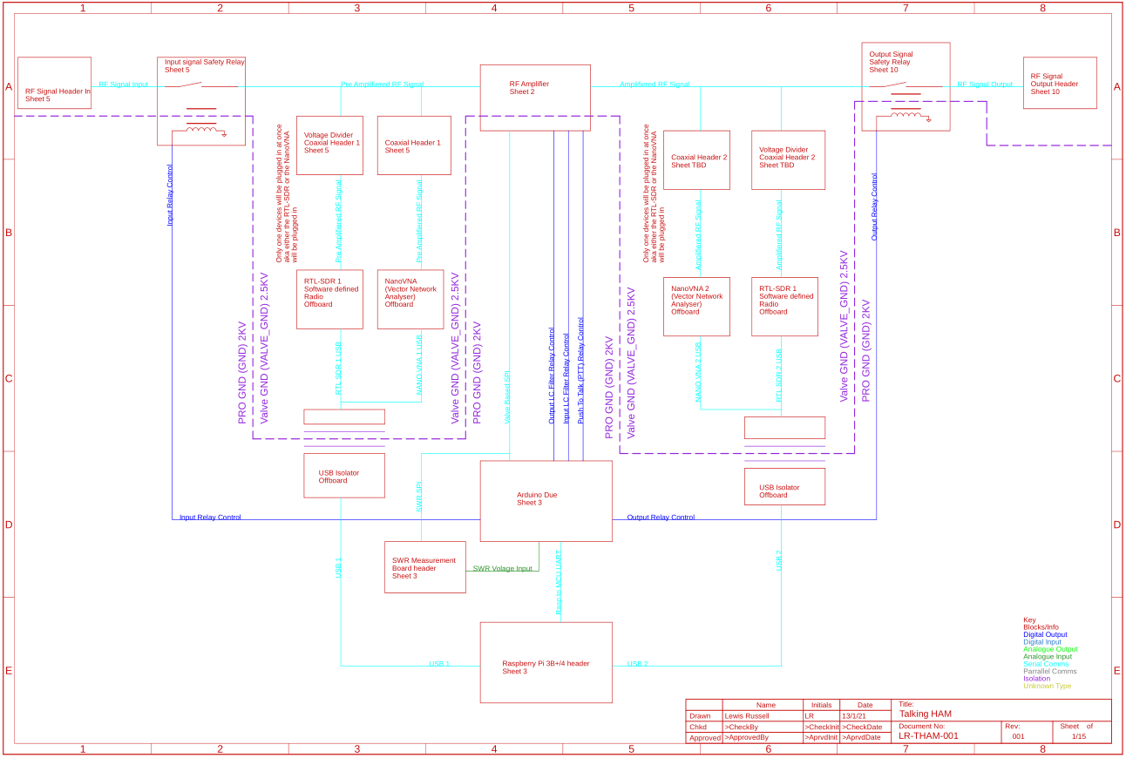

Figure 35:- Fleshed out System Architecture for Talking HAM

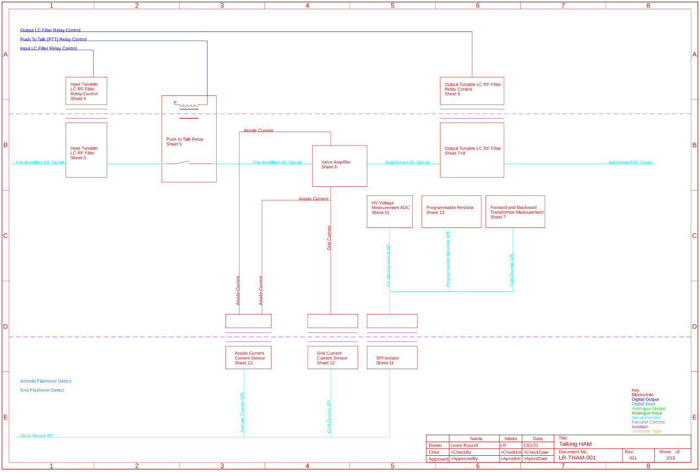

Figure 36:- Valve Amplifier System architecture

## Schematics

The overall design was initially made without modularity in mind, and separated later as this would allow a better idea on how it would be connected.

### Raspberry Pi and Arduino Headers

First the Arduino Due and Raspberry Pi headers were added to show an idea on their pin outs. As well as a UART comms connected up between the two. They have also been set up to use external power, but through 0R Resistors in case power is decided to be provided externally. There is also a SWR Meter Headers, one is set up for Analogue Voltage inputs, as well as a SPI link so that 2 ADCs could be set up externally in order to read the voltages locally, this is for if an external SWR measurement is wanted.

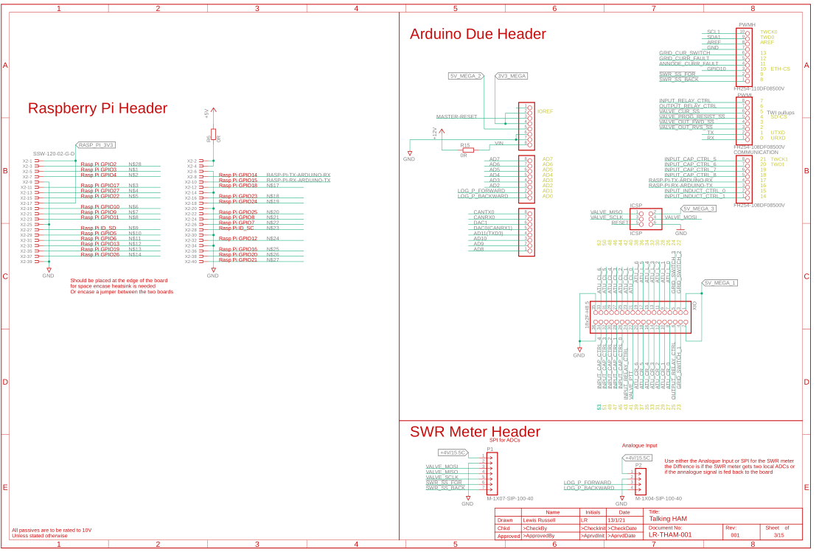

Figure 37:- Raspberry Pi and Arduino Headers

### Input LC Relay Control

The Input LC Is controlled through relays, shown in Figure 38, this is a basic MOSFET control with 2 Diodes for any voltage spikes from the switching of the relays. The 10u Capacitor will also help with current ripple during switch on, when there is a voltage rush. The 4k7 pull down is so if the MCU is every not connected its default state is off. The Relays themselves are ones made by Sensata/Cyneregy3 which are the DAR71210, which are 10KV isolated Reed Relay, with a Coil voltage is 12V. There is two main types the DAR and DAT, with the difference being the contact resistance for the signal, being reduced from 250 mΩ max, 100 mΩ typical using the DAT, Tungsten contacts, down to 50 mΩ max, 15 mΩ typical using the DAR, Rhodium contacts. This is important as in many of the cases these will be being used in LC circuitry, in which we need to minimise the resistance, to prevent it from being a RLC circuit, in turn reducing some losses. A number of different relays were looked at but this was chosen because it offered the best isolation at the cost. And I have used them previously, so I know they are good relays.

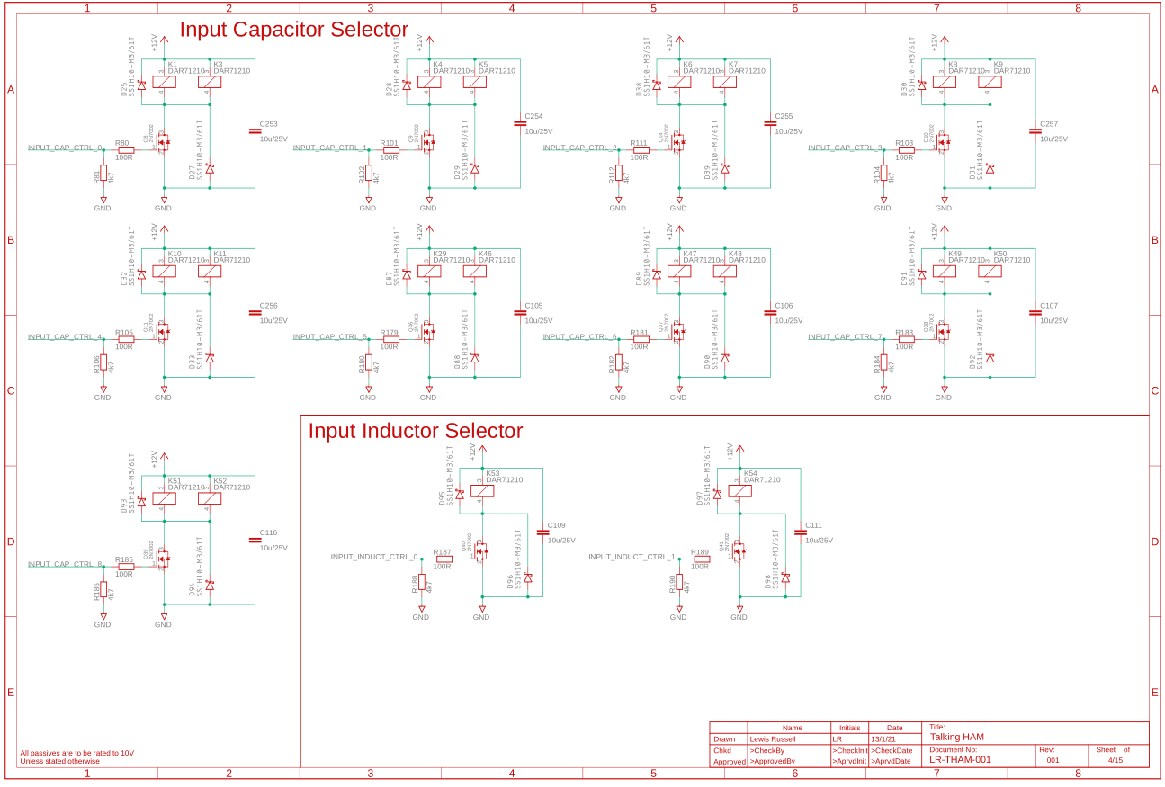

Figure 38:- Input LC Relay Control

### Input Voltage and LC Filter

The input signal is passed in and goes through a cut off relay, which can be turned on and off to enable and disable amplification if there is an issue. After this is passes into a pi filter, this pi filter capacitors were calculated in an excel document giving the results shown in Figure 39. The overall circuit for this is shown in Figure 40.

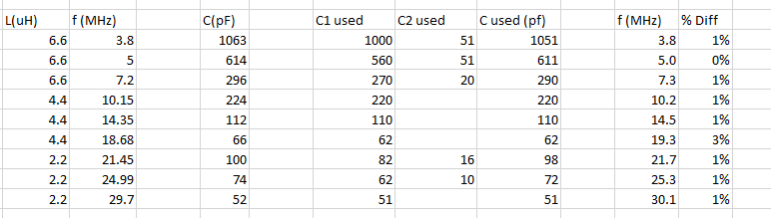

Figure 39:- pi Filter Calcs

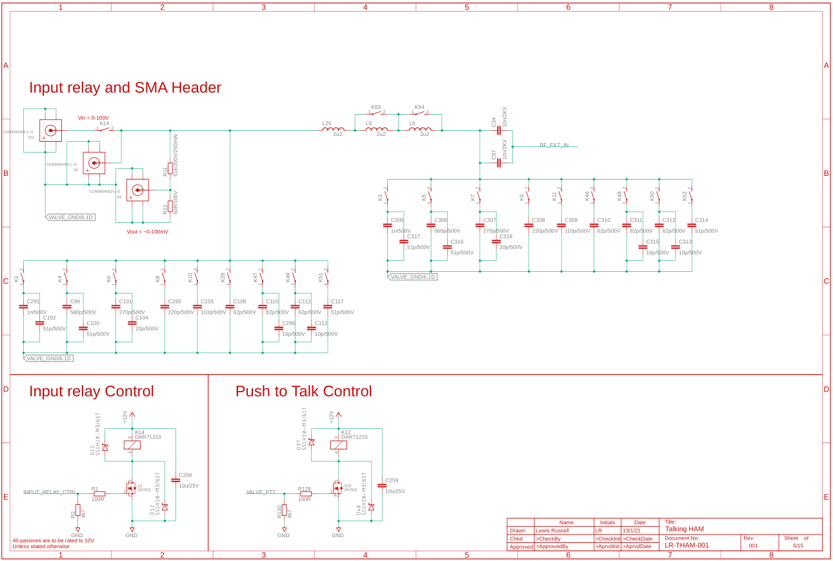

Figure 40:- Input LC Filter

### Amplifier

The amplifier is shown in Figure 41, this shows how the amplifier will be connected, it is unsure how the valve will be connected at this stage, as the holder type is still unknown but I assumed it would be a type which would have lose wires taken up to it.

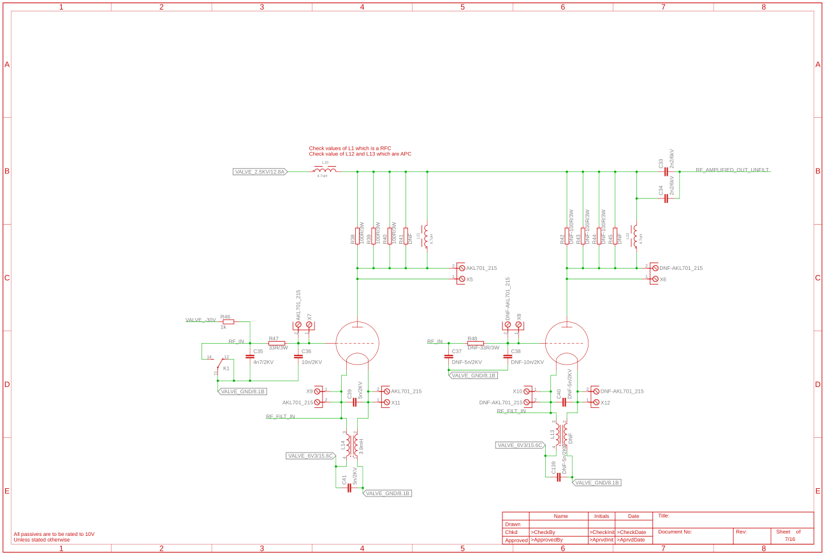

Figure 41:- Amplifier Design

### ATU and SWR

After the signal is amplified is needs to go through an Antenna Tunning Unit (ATU), which turns the signal to resistance match the antenna. The first part of it is shown in Figure 43, with the second part shown in Figure 44, and the relay control for it all shown in Figure 45.

But before it passed into the ATU a Standing Wave Ratio (SWR) measurement needs to be taken, this is done by passing the RF through a transformer, which is a Wideband 2-hole Ferrite Core with the following winding, the main RF signal is passed through one of the holes with some additional insulation to ensure isolation due to HV, with 10 winds round the core as well, this is mirrored on both sides, as shown in Figure 42. Then passed through a resistor, diode and capacitor network in order to get an analogue output able to be read by the ADCs.

The core for the SWR Measurement which is needed is still in production but needs to be bought off ebay, due to shipping costs from the manufactures or stocking suppliers as they charge shipping costs to the UK of upwards of £80, compared to £3 off of ebay, meaning although this component can be brought band new, it is being bought off a no official supplier. This transformer is then used for a, and then it is passed into a pi filter which acts as the matching network for the ATU.

There is diodes on the FWD and RVS/SWR analogue lines, to prevent any voltage spikes from killing the ADCs, as these didoes will clamp any voltage swings.

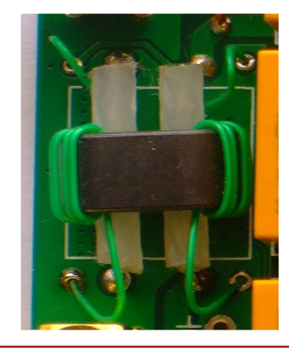 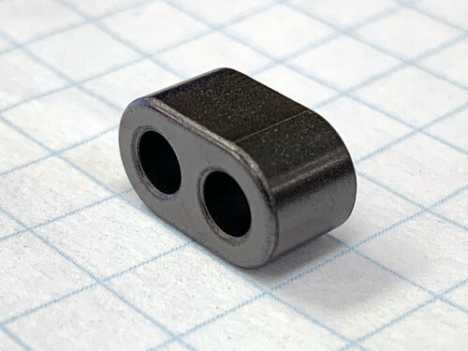

Figure 42:- Transformer Windings and core [24]

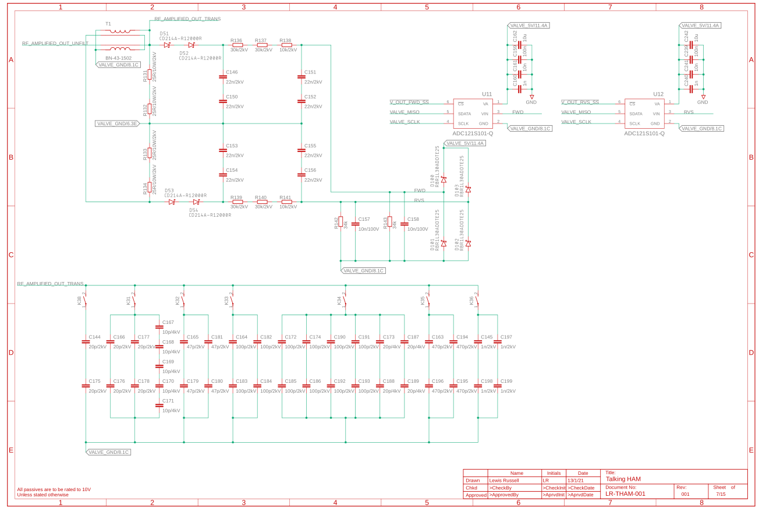

Figure 43:- ATU Part 1

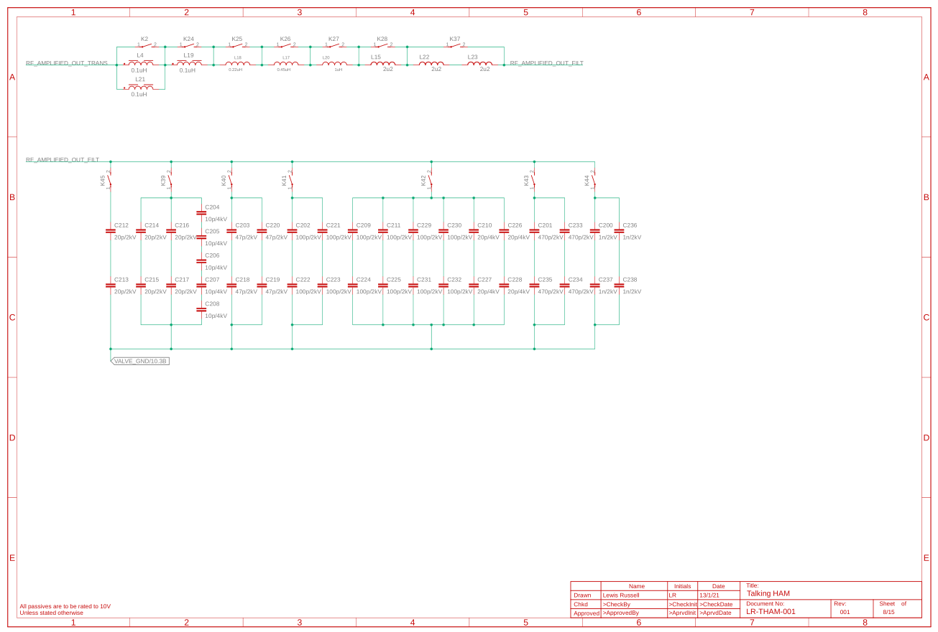

Figure 44:- ATU Part 2

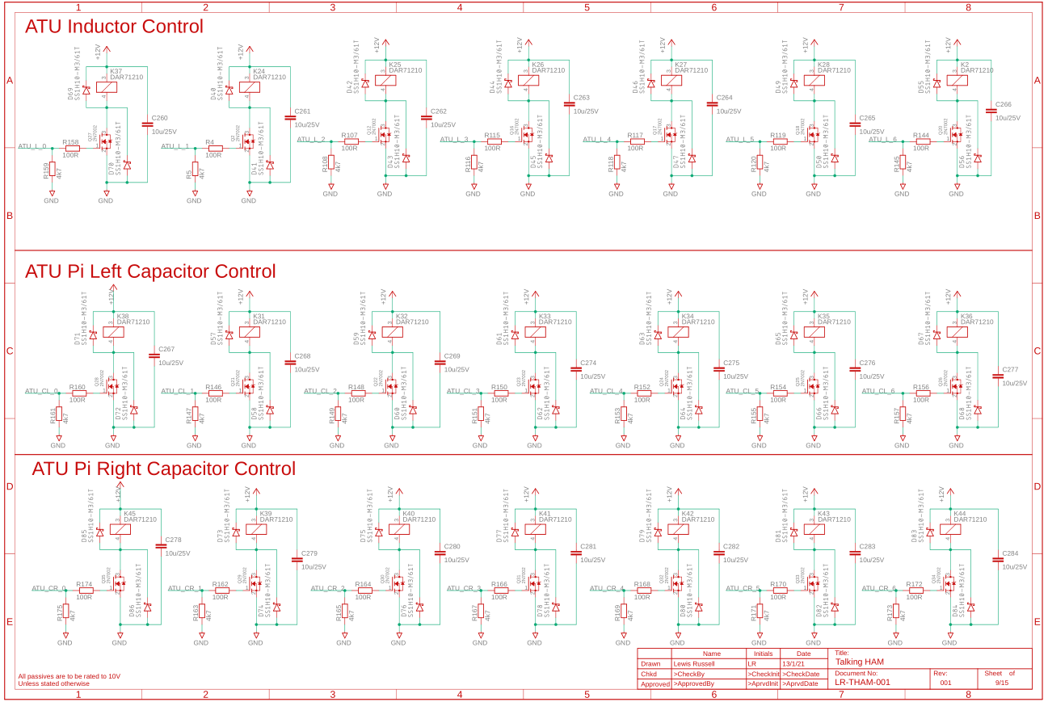

Figure 45:- ATU Relay Control

### Output Control

In this there is a voltage divider over 21 resistors for it for the RTL SDR.

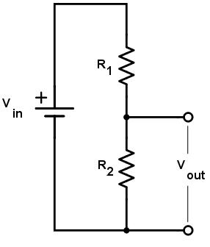

Figure 46:- Voltage Divider [25]

The basics is R2 = 50Ω, with an input voltage of 2500V peak and an output voltage of 0.1 V peak

First the R­­1 Resistance was calculated in Equation 4.

$$V_{o}=V_{i}\frac{R_{2}}{R_{1}+R_{2}} \\ 0.1=2500*\frac{50}{R_{1}+50} \\ \frac{1}{25000}=\frac{50}{R_{1}+50} \\ \frac{R_{1}+50}{25000}=50 \\ R_{1}=1250000-50 \\ R_{1}=1249950Ω \\ R_{1}≈1.25MΩ$$

Equation 4:- Voltage Divider Resistance

Next the power of the voltage divider was calculated in Equation 5

$$P=\frac{V^{2}}{R} \\ P=\frac{{2500}^{2}}{125*{10}^{6}} \\ P=5W$$

Equation 5:- Power of Voltage Divider

This power needs to be split over several resistors, the power of the 50R will be rather small as only 0.1V is passing over it, but the other resistors is where majority of the power will be dropped. For a good safety margin, 20 500mW resistors will be used, meaning each resistor will drop 250mW. The reason for this is you don’t want to run resistors too close to their power limit for both thermal and lifetime reasons so a 50% margin is the best. That and also using 20 resistors means 63k8 resistors can bee used, which have a wider range of options than 10 resistors. The resistance of this chain however is 1.3 MΩ, which will change the output to be 0.096V Peak, which is not an issue.

There is also another emergency disconnect relay encase there is an issue and the device needs to be shut down.

The circuit is shown in Figure 47.

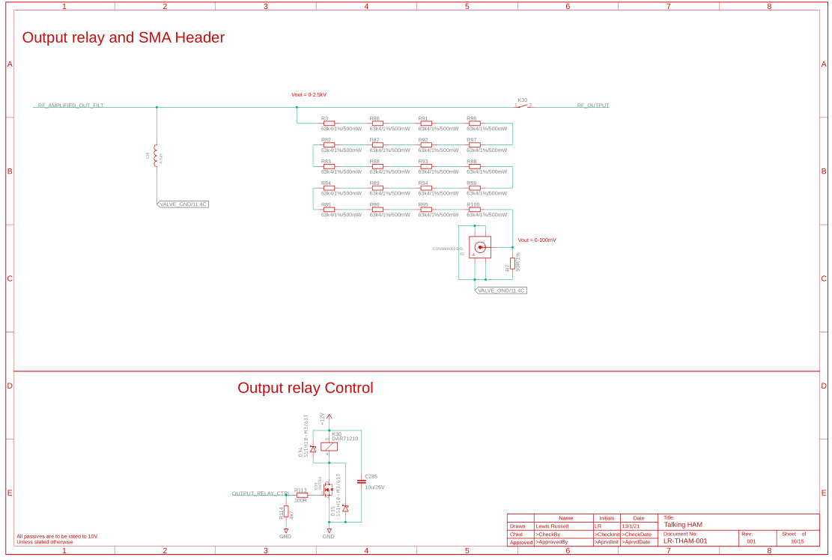

Figure 47:- Output Stage Circuit

### SPI Isolators and Voltage Measurement

The SPI Isolators and voltage measurement is shown in Figure 48. This shows a voltage divider which has been used to divide the 2.5kV down to 2.45V. The resistors being used for this are all over kill, but are needing to be used due to them being able to withstand a 500V drop across them, as several lower power resistors would not be able to withstand these voltage drops, so this means that 2W parts are being used for a 0.31W load. So in this case it is the voltage which is the driving factor.

The RBR1L30ADDTE25 Schottky Diode is being used as it has a very low reverse current of 50uA @ Vreverse = 30V­, which is important, as there is only 744uA flowing, with a reverse voltage of around 3V meaning the reverse current should be <1uA which is required in normal operation.

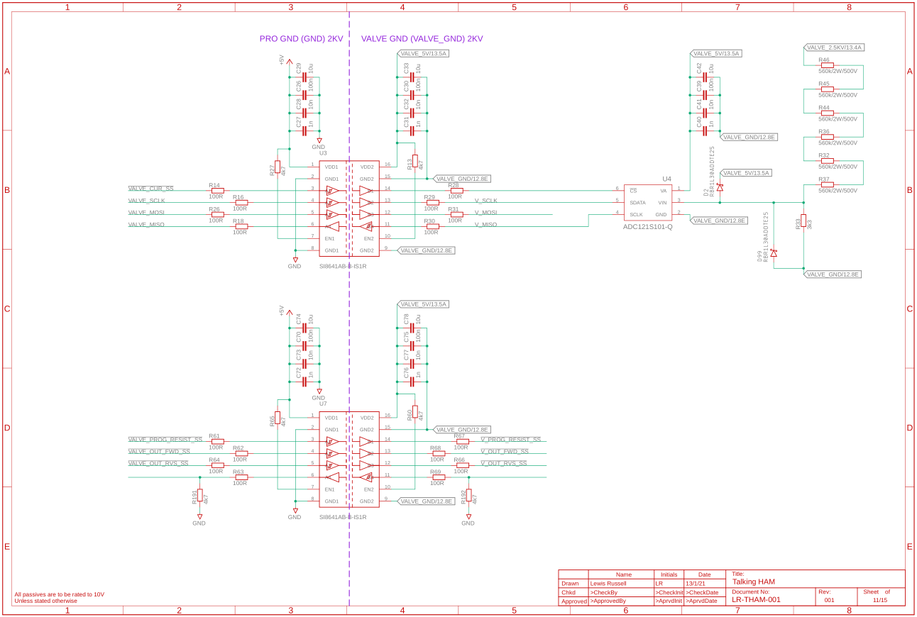

Figure 48:- Isolators and Voltage measurement

### Valve power

The valve relay control and current sensors are shown in **Error! Reference source not found.**. This has the MCA1101-5-5 current sensors, which can measure up to 5A, with an internal isolation strength of 4.9 kV

The voltage for the valves is generated as shown in Figure 49. This full bridge rectifies the output from a Hammond Manufacturing 726A Transformer, which will output roughly 1.78KV RMS, which when rectifies will give around 2517V, which is what is required for the valves, providing 202 mA, which is around 350W, which is enough for this point in testing, although this may be expanded upon at a later date if more power is needed.

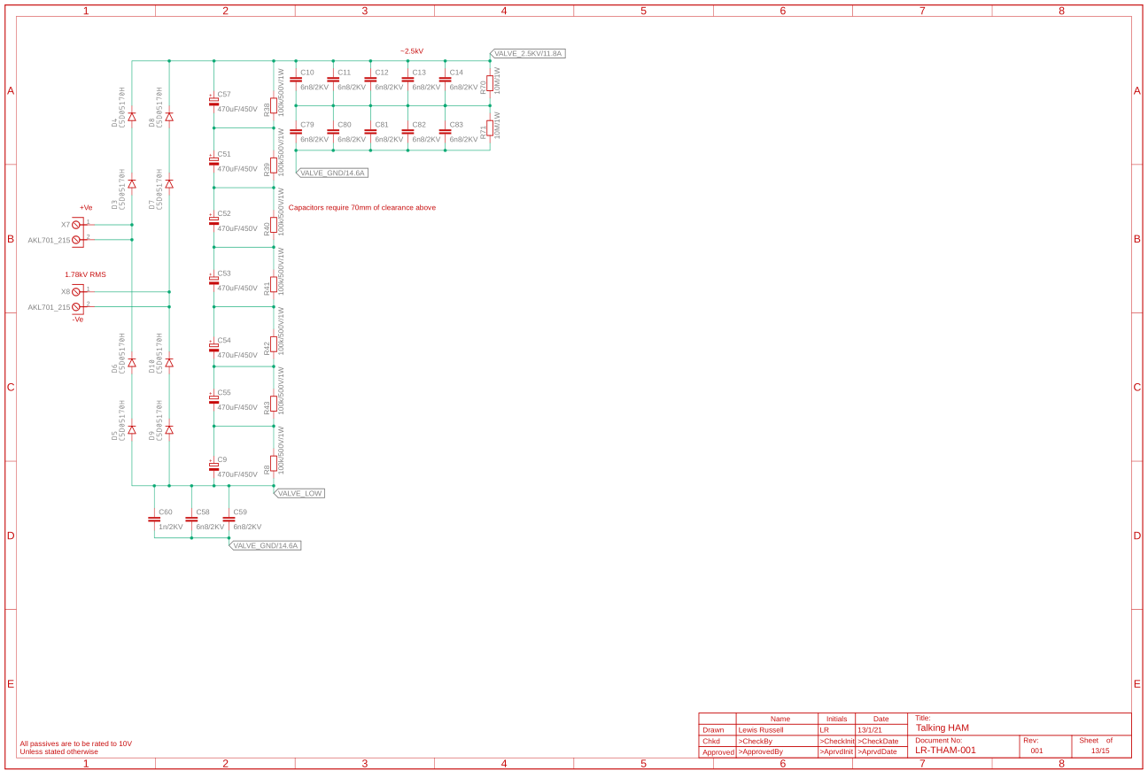

Figure 49:- Grid Power Generation

### Voltage Regulation

The voltages for the system have are created and regulated in Figure 51 and Figure 52.

A full power budget was done, which resulted in the Figure 50, which shows the main power draws for each system. This shows that the max power draw for 12V is 45W, meaning a 60W will do, same with the Valve 12V, the Valve 6V3 is drawn from the Valve 12V.

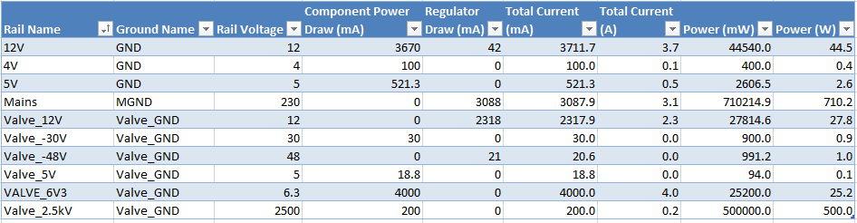

Figure 50:- Power Budget for the System

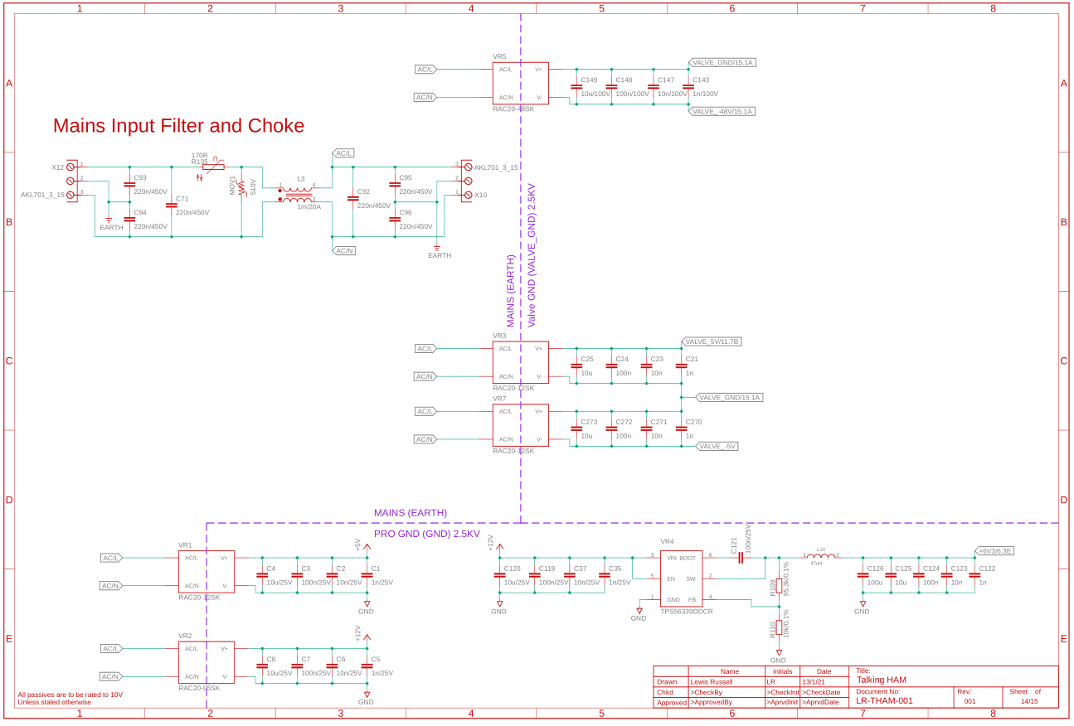

Figure 51:- Voltage Regulation 1

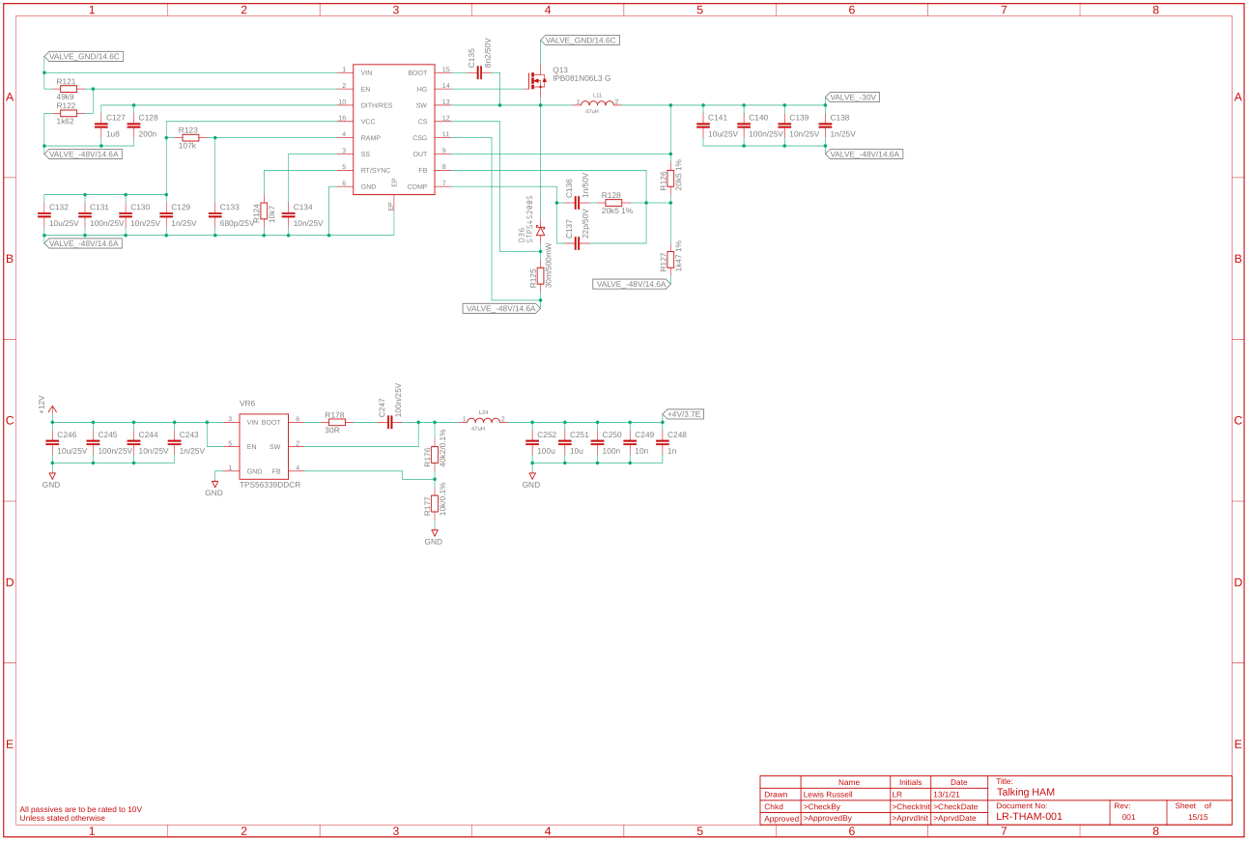

Figure 52:- Voltage Regulation 2

### BOM

A Bill of Materials (BOM) was completed for the system, and the total cost of the system is expected to be around £2030 per unit just for the base components, plus the cost for the PCB manufacturing.

### First design review

It was decided that the cost was too great and should be cut down, it was also decided that the overall design was not in a state that it. But the review is shown in Table 1. This was done with Matthew Love at Mage Control.

Table 1:- PDR 1

|  |
| --- |
| **Change** |
| Change Relays to standard relay to reduce cost |
| Change to have a 3PDT for the RF Input and output for Antenna switching or 3 relays in parrallel |
| Change RF inductors for the ATU to toroids (Q > 30). OD 25-30 T80-6+ (toroids.info) |
| Change Push to Talk to have a hardware button, 2 pin screw terminal |
| Change filter capacitor and inductors to values copied direct from ATU 100 Mini |
| Break up into Modular Design |
| Use the sockets for the valves |
| The 100R and APC and RFC for the Valve will be external components to the PCB |
| Change Bucks on valves to a LDO, or a transformer with bridge rect as the switching noise could cause noise on the RF output |
| RF header should SMA Connectors, but output should be done through 2 pin screw terminals due to voltage |
| Add a DNF Op Amp in for Current sensing encase output voltage is too low. |
| Add grid current measurement on -30V line. Grid Current = 25-50mA Max 60mA |
| Change caps for HV Bulk to cheaper ones off CPC, CA08626. Same Package |
| Change caps from SMD to TH for better voltage ratings |
| Change Common Mode Choke for the AC and the Valve to a cheaper higher inductance one. 4A min |
| Change to cheaper AC/DC Converters or to transformers |
| Remove the Valve 12V just for the 6V3 and move to a Transformer and rectifier |
| System Architecture is missing the antenna header, and switch for connecting antenna to the input |

## Modular Design Schematics

The design was broken up into multiple boards initially the system architecture for this new system was drawn as shown in Figure 53. This has been adapted to show what board each section of circuitry is shown. On top of this the power architecture was added and the overall architecture has been tided up so it was better looking.

|  |  |
| --- | --- |
| Overall System Architecture | Valve Amplifier |
| Power Architecture |  |

Figure 53:- Modular System Architecture

### RF-PWR-001 Schematics

Initially the RF-PWR Schematics were made, this is shown in Figure 58. This has its own system architecture shown in Figure 54. This shows how mains comes in on a header, passes through a choke, then passed output to several Low Voltage transformers which is then rectified and passed into some current sensors and then out to other boards. Mains is also passed out to a HV transformer which rectified then passed out to the amplifier, this is also divided down for an ADC. The mains is also passed out to a number of a AC/DC transformers for the remaining Valve and GND powers which goes to a header for a number of different boards. On this sheet there is also a SPI header coming onto the board this SPI is then fed into two ADCs which are for the Plate and Grid current ADCs which connect to the current sensors through an Op Amp. The SPI also passed through a isolator which is then passed out to a digital IO header and to the HV voltage measurement board.

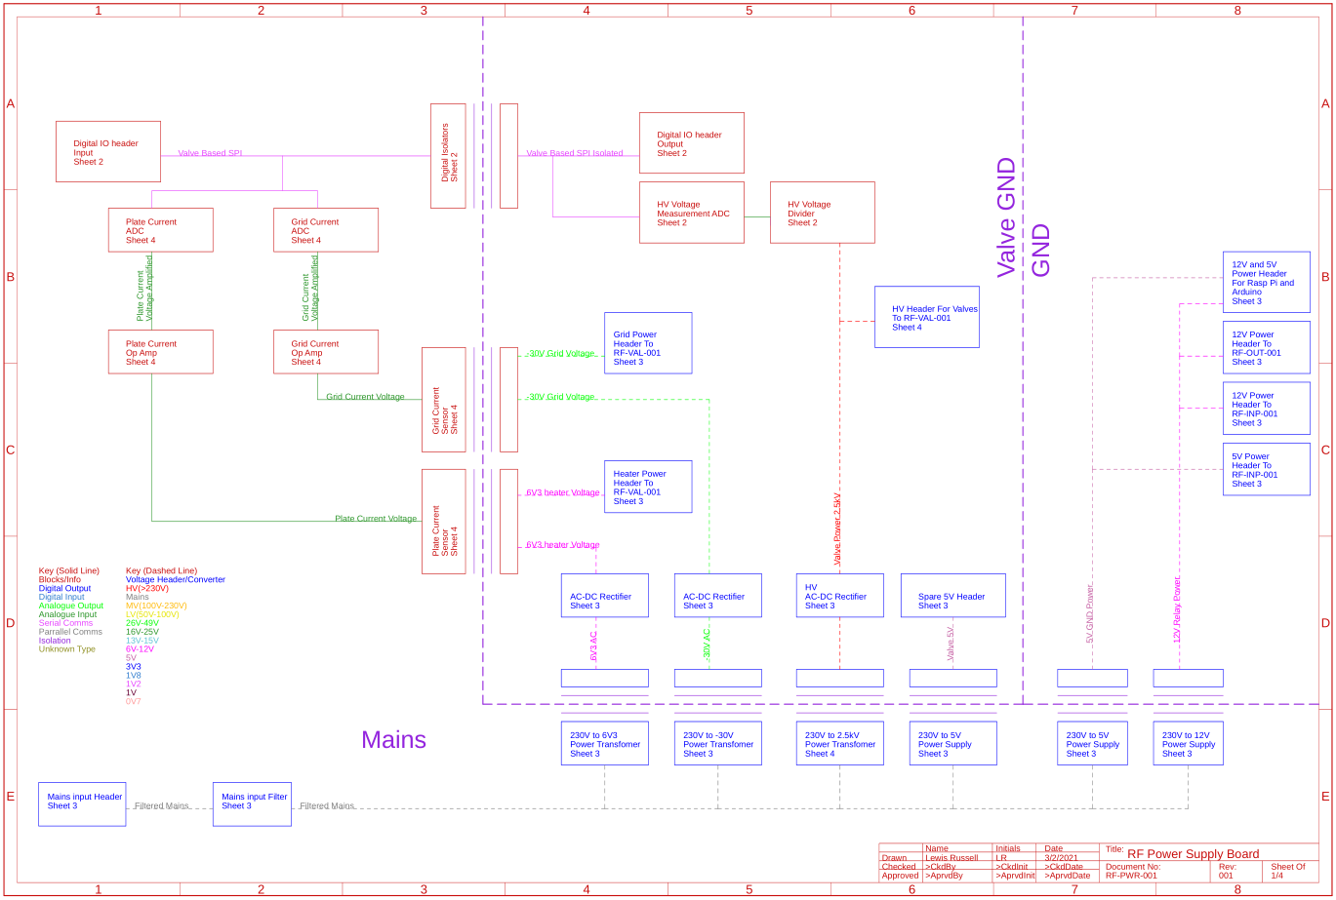

Figure 54:- System Architecture for the RF-PWR-001

The isolation and HV board are shown in Figure 55. This shows how SPI comes on P1, which then passes into the isolators, on the other side of the isolator this SPI passes into the ADC on U1 which also has the voltage divider this has two clamping diodes which clamp the voltage to the power rails. This isolated SPI is then passed out to a SPI header for other boards.

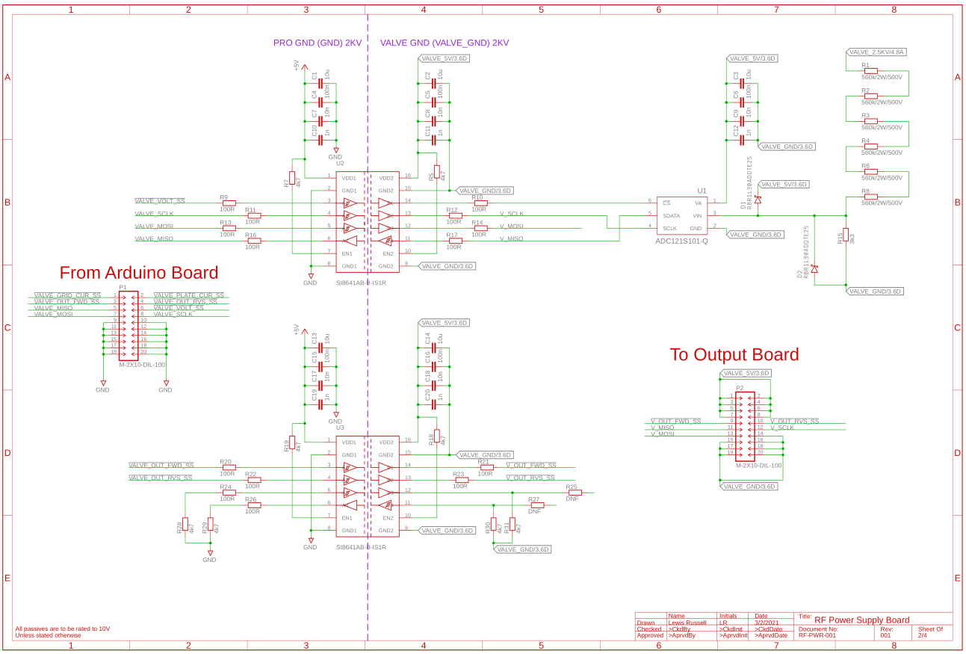

Figure 55:- RF-PWR-001 Isolators and HV ADC

The LV regulation is shown in Figure 56, this has the mains voltage is passed in through X1 and through as filter which is then passed out through headers to the HV transformer, 5V and -30V the mains is also passed into a range of AC/DC converters for Valve 5V, and 5V and 12V for GND. There is also a DNF 4V buck converter for SWR measurement although as its DNF it won’t be used yet. The amount of heat in the 6.3 V diodes were calculated in Equation 6, Equation 7, Equation 8, Equation 9 and Equation 10 using the datasheet extract in Figure 57. This shows that the diodes will be able to keep under temperature under a worst-case scenario, meaning in more real scenarios they would be able to stay under temperature as well. This was then done again for -30 V are shown in Equation 11, Equation 12, Equation 13, Equation 14 and Equation 15 and it found the temperature rise is minimal.

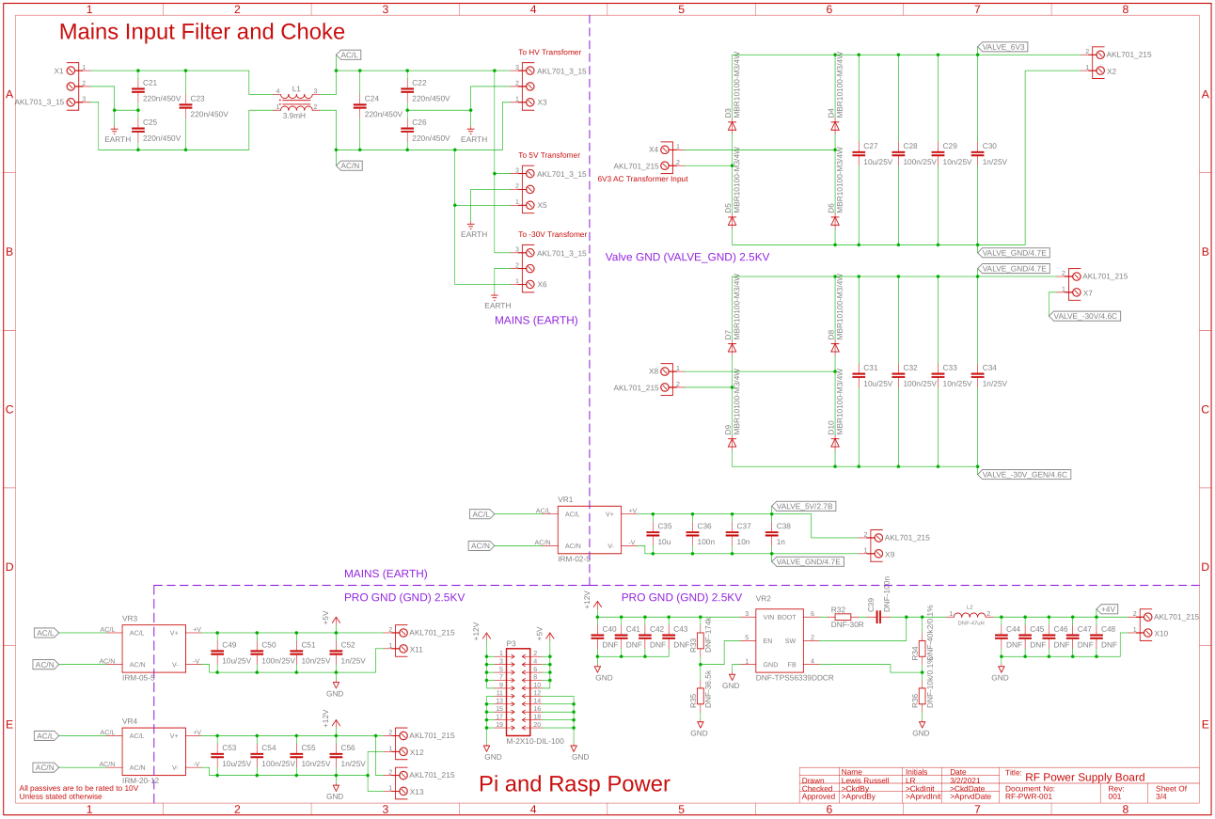

Figure 56:- RF-PWR-001 Mains Input and Voltage Regulation

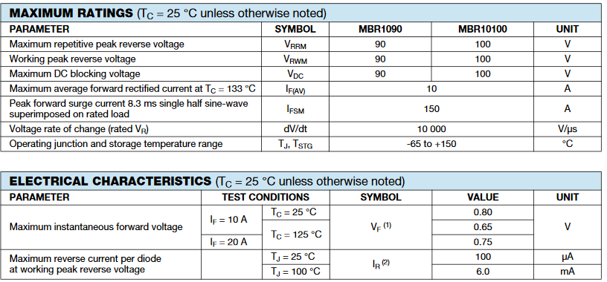

Figure 57:- MBR10100-M3/4W Diode Datasheet extract [26]

$$P_{con6V3}=η_{con}I_{f}V_{f} \\ P_{con6V3}=0.5*4*0.8 \\ P_{con6V3}=0.5*3.2 \\ P_{con6V3}=1.6 W$$

Equation 6:- Conduction Power Losses for 6V3

$$P_{leak6V3}=\left(1-η_{con}\right)I_{r}V_{r} \\ P_{leak6V3}=\left(1-0.5\right)*6*{10}^{-3}*6.3 \\ P_{leak6V3}=0.5*37.8*{10}^{-3} \\ P_{leak6V3}=18.9 mW$$

Equation 7:- Leakage Power Loss for 6V3

$$P_{loss6V3}= P_{leak6V3}+P_{con6V3} \\ P_{loss6V3}= 1.3+0.0189 \\ P_{loss6V3}= 1.6189 W$$

Equation 8:- Total Power Loss for 6V3

$${∆T}_{6V3}=P_{loss6V3}*R_{T6V3} \\ {∆T}_{6V3}=1.6189*60 \\ {∆T}_{6V3}=97.134 °C$$

Equation 9:- Temperature Delta for 6V3

$$T_{max6V3}=T_{ambiant}+{∆T}_{6V3} \\ T_{max6V3}=40+97.134 \\ T_{max6V3}=137.1 °C$$

Equation 10:- Maximum Temperature for 6V3

$$P_{con30V}=η_{con}I_{f}V_{f} \\ P_{con30V}=0.5*60*{10}^{3}*0.8 \\ P_{con30V}=0.5*48*{10}^{-3} \\ P_{con30V}=24 mW$$

Equation 11:- Conduction Power Losses for 30V

$$P_{leak30V}=\left(1-η_{con}\right)I_{r}V_{r} \\ P_{leak30V}=\left(1-0.5\right)*6*{10}^{-3}*30 \\ P_{leak30V}=0.5*180*{10}^{-3} \\ P_{leak30V}=90 mW$$

Equation 12:- Leakage Power Loss for 30V

$$P_{loss30V}= P_{leak30V}+P_{con30V} \\ P_{loss30V}= 24+90 \\ P_{loss30V}= 114 mW$$

Equation 13:- Total Power Loss for 30V

$${∆T}_{30V}=P_{loss30V}*R_{T30V} \\ {∆T}_{30V}=0.114*60 \\ {∆T}_{30V}=6.84 °C$$

Equation 14:- Temperature Delta for 30V

$$T_{max30V}=T_{ambiant}+{∆T}_{30V} \\ T_{max30V}=40+6.84 \\ T_{max30V}=46.8 °C$$

Equation 15:- Maximum Temperature for 30V

This shows the HV transformer input which is then passed through some diodes with heatsinking, this is required as the diodes do not have a thermal resistance to ambient so a heatsink is required to make sure, this temperature is shown in Equation 16, Equation 17, Equation 18, Equation 19, Equation 20 and Equation 21 this data was taken from Figure 59 for the diode and Figure 60 for the heatsink.

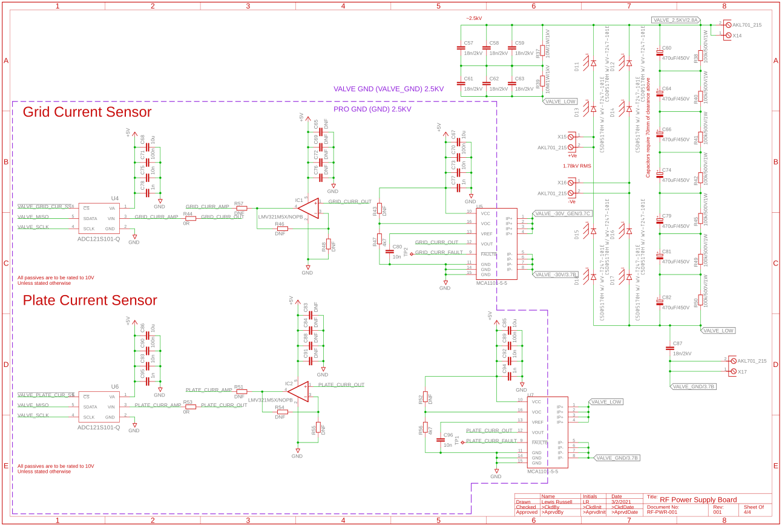

Figure 58:- RF-PWR-001 Schematics HV Rectification and Current Sensing

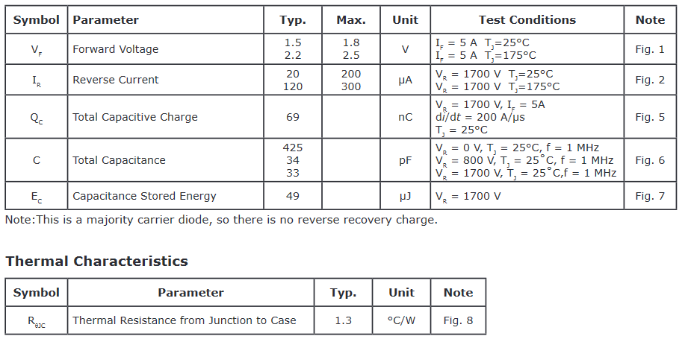

Figure 59:- C5D05170H Diode Datasheet extract [27]

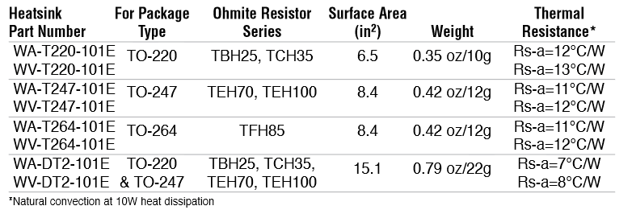

Figure 60:- WV-T247-101E Heatsink Datasheet Extract [28]

$$P_{con2.5kV}=η_{con}I_{f}V_{f} \\ P_{con2.5kV}=0.5*0.202*2.5 \\ P_{con2.5kV}=0.5*0.505 \\ P_{con2.5kV}=0.2525 W$$

Equation 16:- Conduction Power Losses for 2.5 kV

$$P_{leak2.5kV}=\left(1-η_{con}\right)I_{r}V_{r} \\ P_{leak2.5kV}=\left(1-0.5\right)*0.3*1.25 \\ P_{leak2.5kV}=0.5*0.375 \\ P_{leak2.5kV}=0.1875 W$$

Equation 17:- Leakage Power Loss for 2.5kV

$$P_{loss2.5kV}= P_{leak2.5kV}+P_{con2.5kV} \\ P_{loss2.5kV}= 0.1875+0.2525 \\ P_{loss2.5kV}= 0.44 W$$

Equation 18:- Total Power Loss for 2.5kV

$$R_{T2.5kv}=R_{WV-T247}+R_{J-HS} \\ R_{T2.5kv}=12+1.3 \\ R_{T2.5kv}=13.3 °C/W$$

Equation 19:- Total Thermal Resistance for 2.5 kV

$$∆T=PR_{T2.5kv} \\ ∆T=0.44*13.3 \\ ∆T=5.852 °C$$

Equation 20:- Temperature Delta for 2.5 kV

$$T_{max}=T_{ambiant}+∆T \\ T_{max}=40+5.852 \\ T_{max}=45.852 °C$$

Equation 21:- Maximum Temperature for 2.5 kV

### RF-INP-001 Schematics

The RF-INP-001 system architectures are shown in Figure 61, this shows how the RF signal comes on through a RF header through a safety relay then back out to another RF header for a VNA and through a divider for a SDR header. This then passes through a antenna selector to select between connecting the antenna for transmitting or receiving, this then passes the RF though a LC filter then out to an amplifier. This also shows how this is controlled by a header which is from an Arduino which controls the filter and safety relay. On top of a PTT button is also used for the antenna selector and a header for the amplifier.

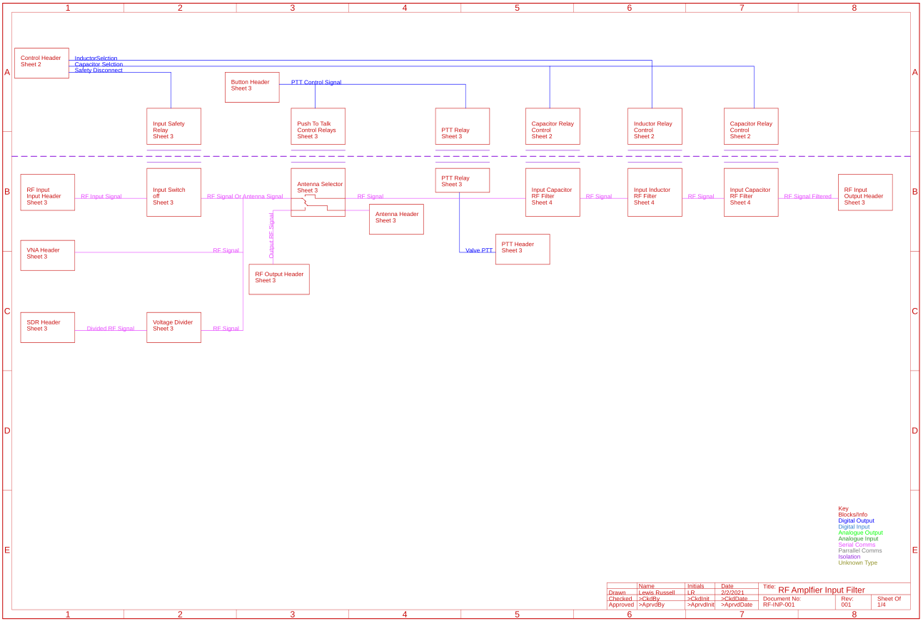

Figure 61:- RF-INP-001 System Architecture

The control for the LC filter is shown in Figure 62, this shows where the LC filter controls came on and then passed out to the relay controls among the page.

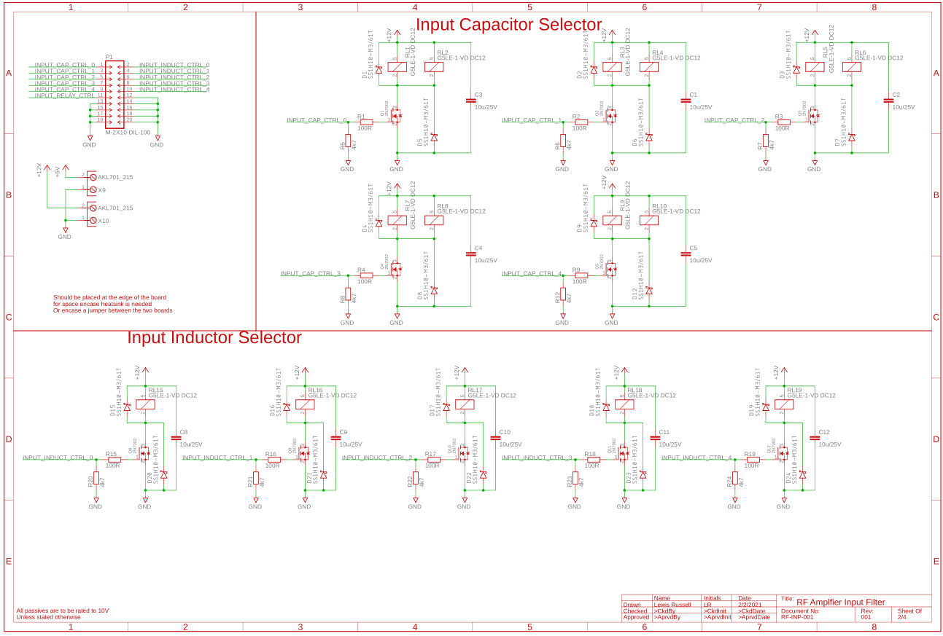

Figure 62- RF-INP-001 LC filter Control

Figure 63 shows the RF input which passes through a safety relay and then back out to the VNA and the SDR through its voltage divider and then into the antenna selector, which either connects the input RF with the LC filter and then amplifier and the RF output to the antenna header or the directly input RF to the antenna for receiving. It also shows the relay for the valve PTT control on top of this the safety relay control is shown and the PTT button control.

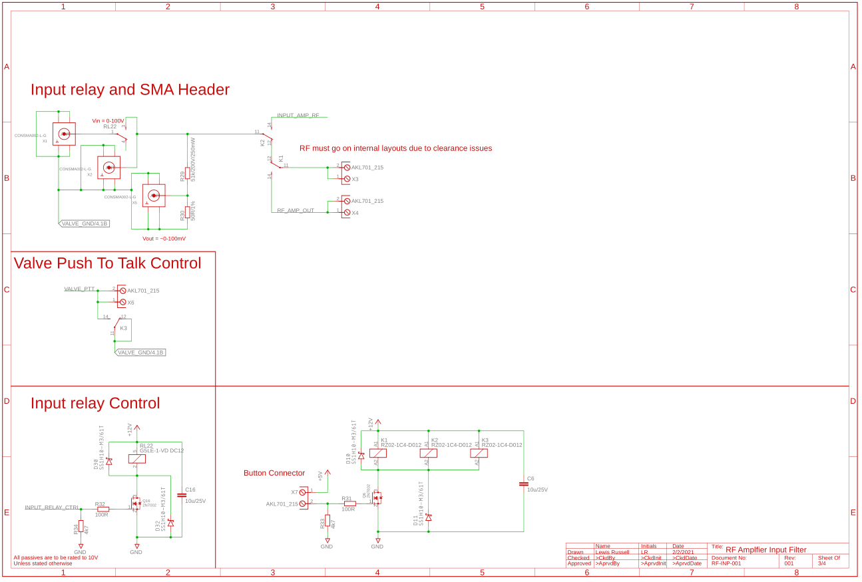

Figure 63:- RF-INP-001 RF input.

Figure 64 shows the LC filter, these values were copied from the ATU-100 mini, but using larger inductors and capacitor ratings for a higher power rating. There is also a HV capacitor inline to prevent any DC voltage being on the line.

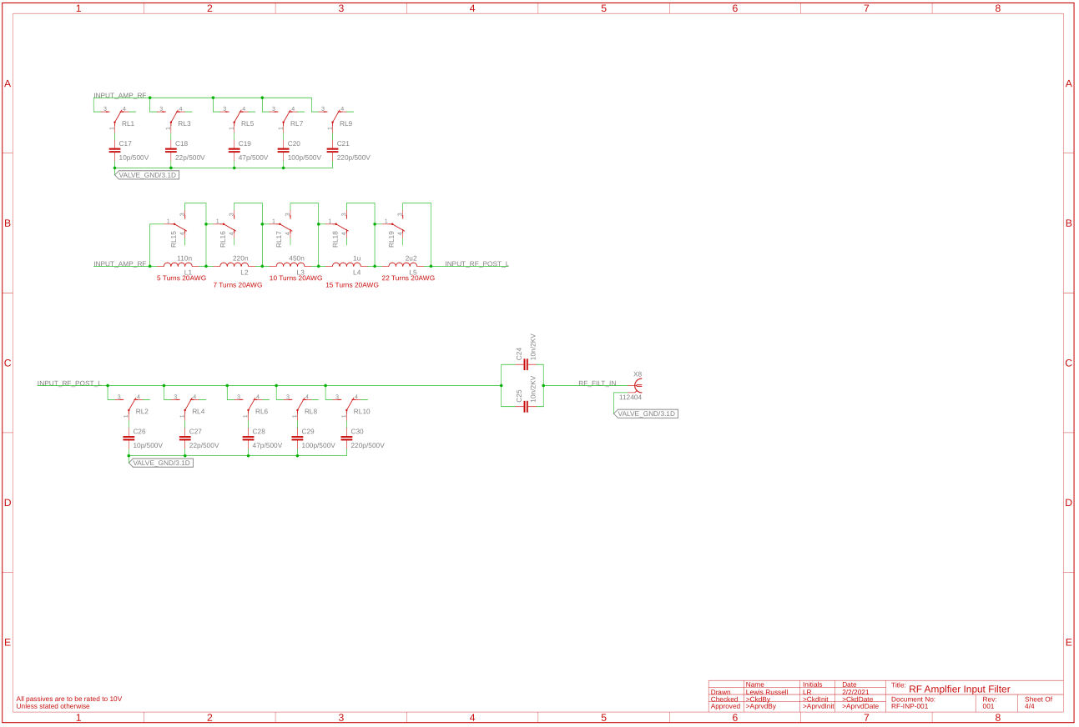

Figure 64:- RF-INP-001 LC Filter

### RF-OUT-001 Schematics

Figure 65 shows the RF-OUT-001 system architecture this shows the RF output signal getting passed through a SWR transformer and measurement, then into a LC filter similar to RF-OUT-001, and then divided down for a SDR and then through a safety relay and outputted.

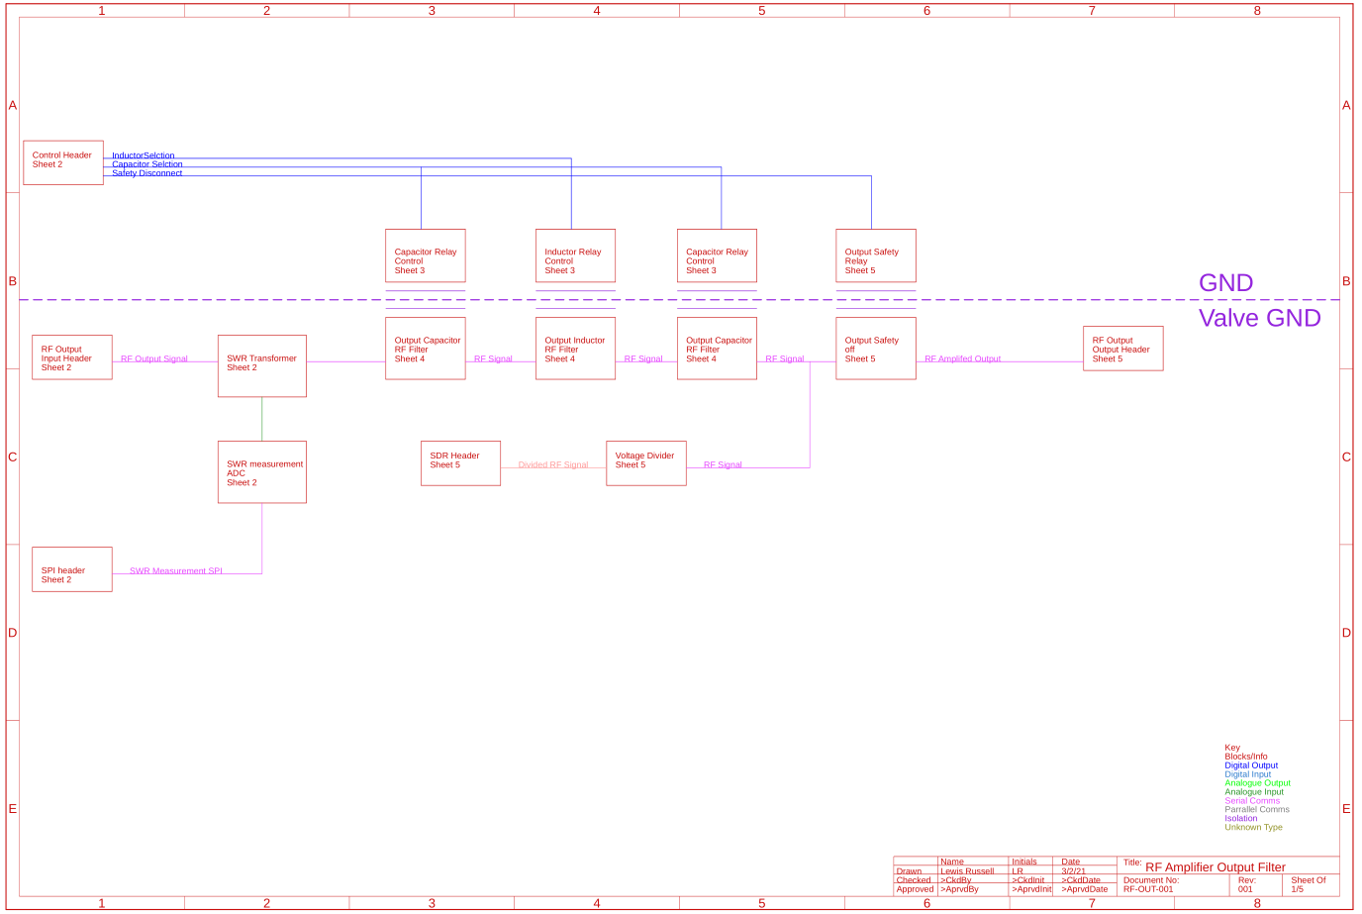

Figure 65:- RF-OUT-001 System Architecture

Figure 66 shows the SWR measurement this is copied from the ATU-100 mini but has been adapted for a higher power HV situation.

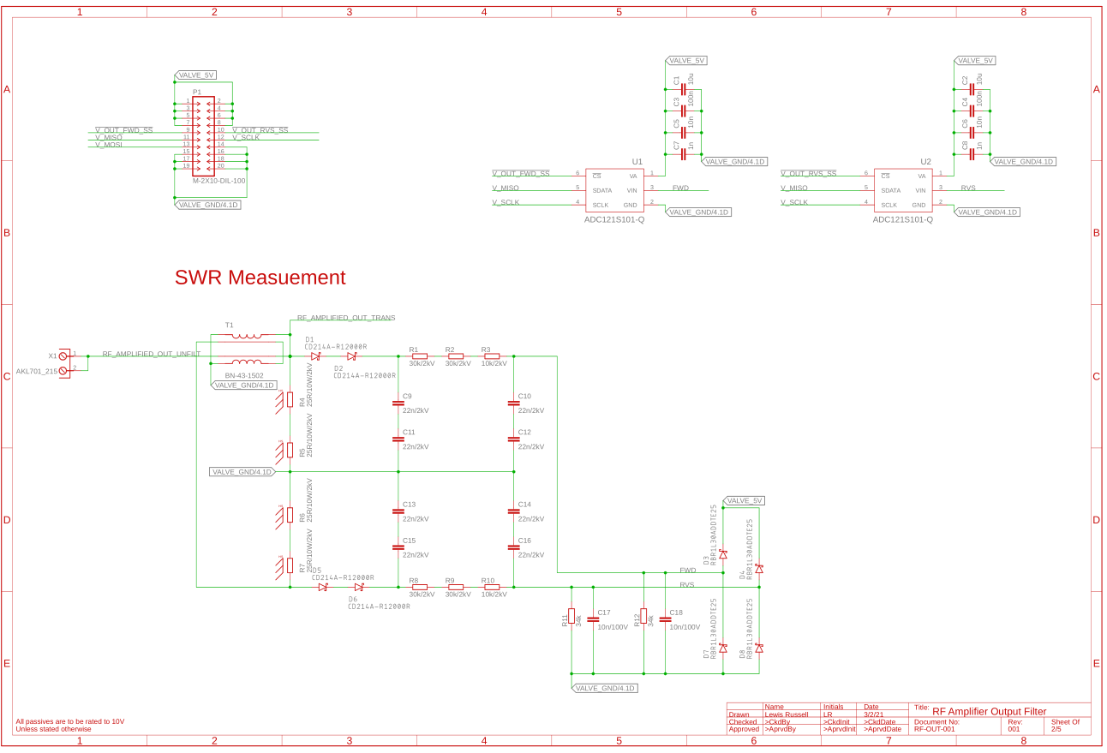

Figure 66:- RF-OUT-001 SWR measurement

Figure 67 shows the relay control for the LC filter, this is similar to the RF-INP-001 Board.

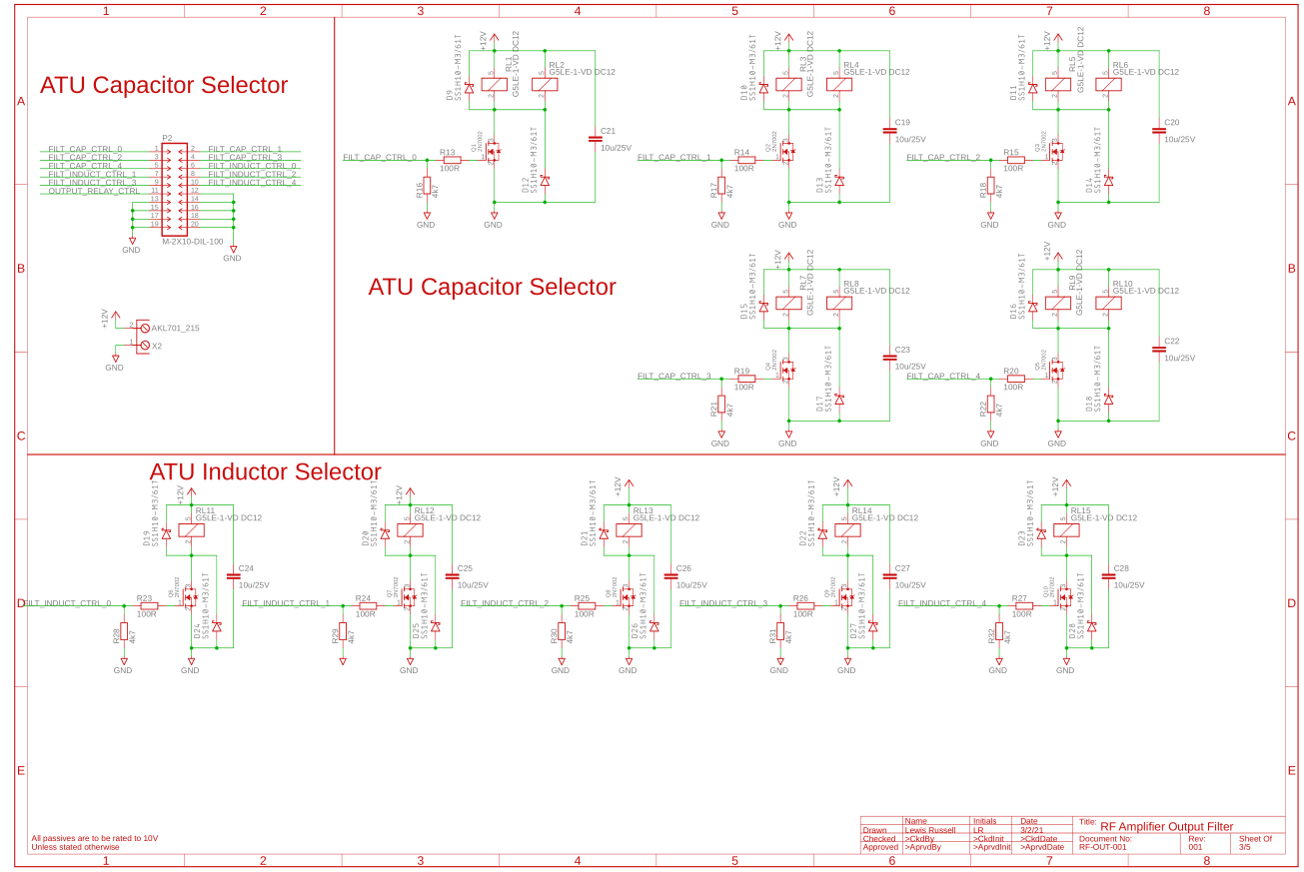

Figure 67:- RF-OUT-001 ATU Relay Control

Figure 68 shows the LC filter, these valves are from the ATU-100 mini but with larger inductors, the same as in RF-INP-001 but it is rated for a much higher power

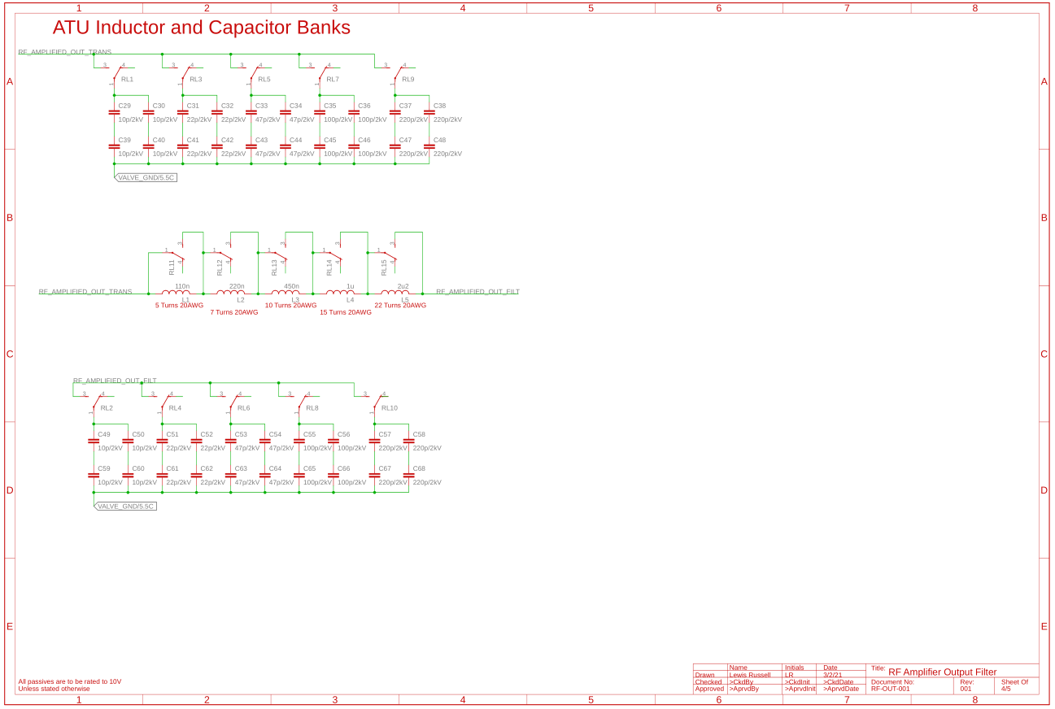

Figure 68:- RF-OUT-001 LC Filter

Figure 69 shows the output of the RF-OUT-001 board, this shows the voltage divider for the SDR and the safety relay and control.

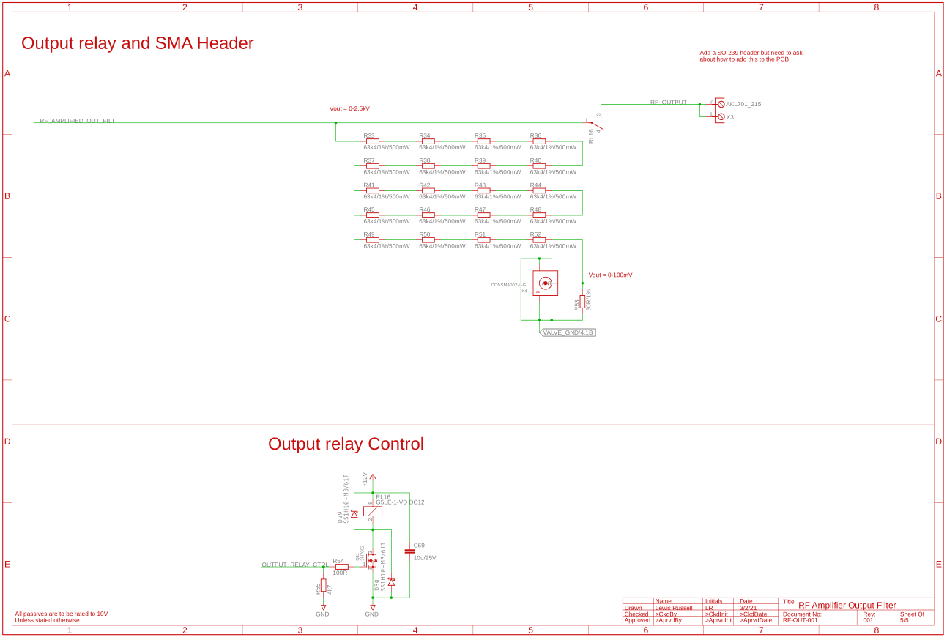

Figure 69:- RF-PWR-001 Output

### RF-VAL-001 Schematics

Figure 70 shows the RF-VAL-001 valve amplifier this single board will be used for the amplifier, and can be added in parallel to scale the power up. This shows the how the PTT control comes on and controls the amplifier on top of this a power for the heater is inserted and passes through a choke and connected with the RF signal passing it into the cathode to be amplified, this amplified signals then outputs to external components connected to the anode cap.

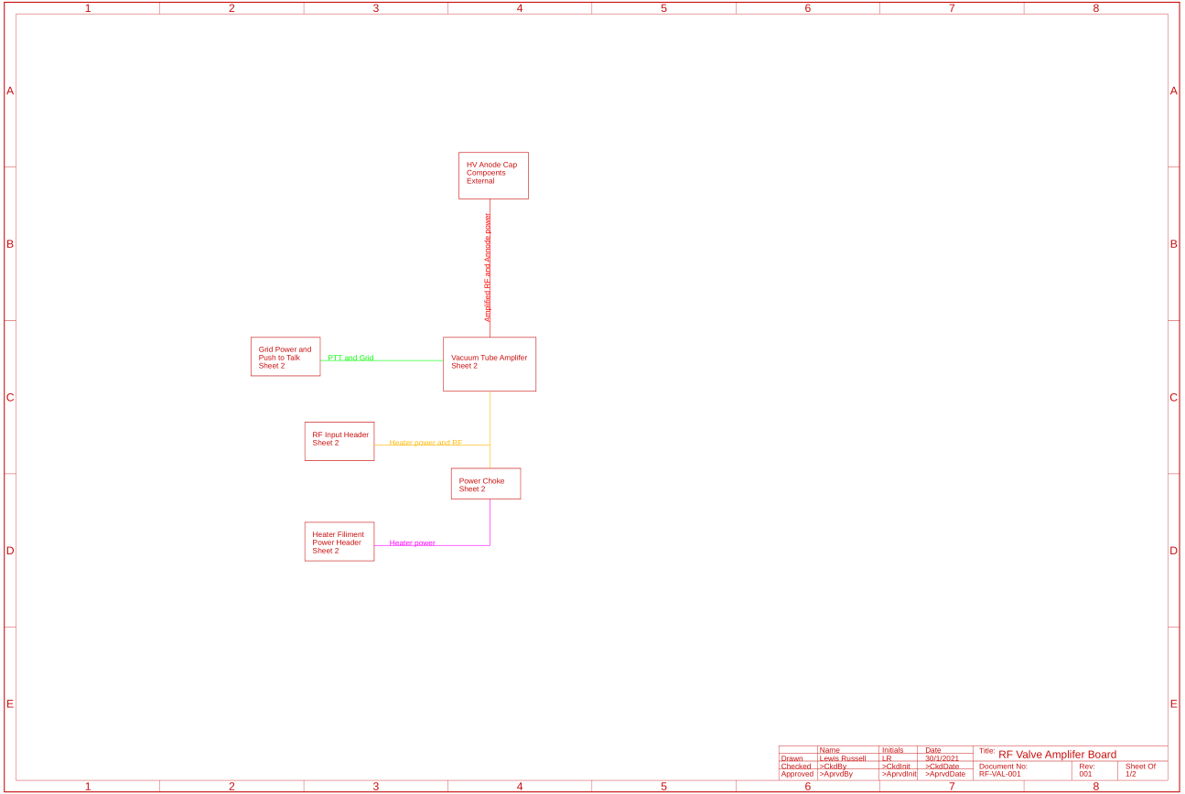

Figure 70:- RF-VAL-001 System Architecture

Figure 71 shows the actual valve amplifer, this compares to the system architecture, which shows the PTT signal coming in and connecting up to the -30V rail and passed through a resistor to the valve amplifier. On top of this it shows the 6V3 input going through a choke and combining onto the RF input and passing into the valve cathode. There is also components added on the valve cap which is used to insert the 2.5 kV valve and where the RF is extracted.

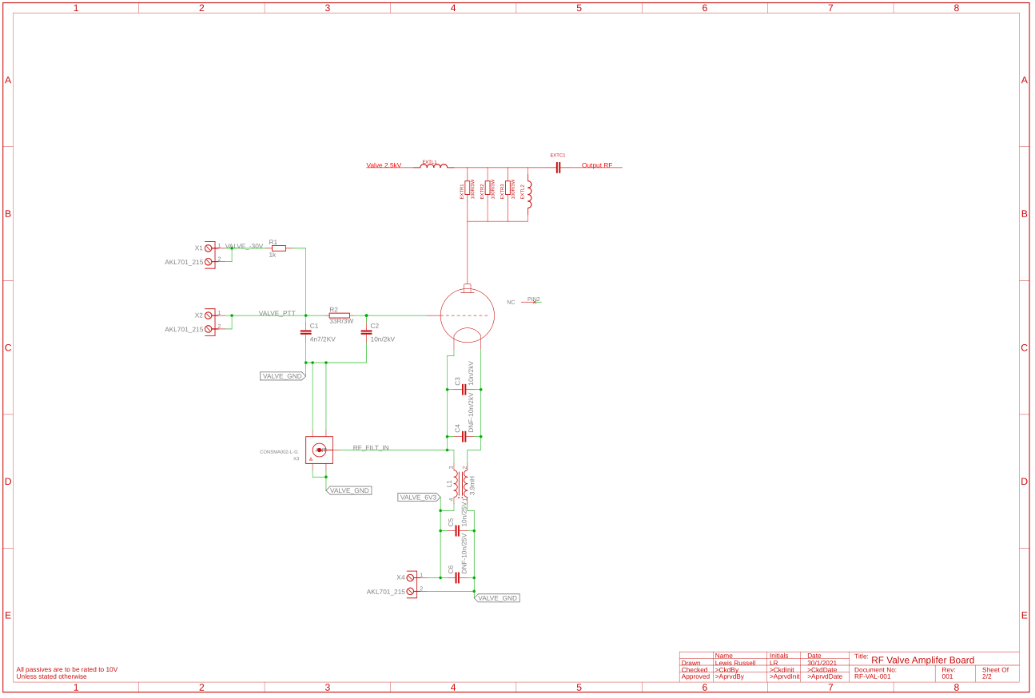

Figure 71:- RF-VAL-001 Valve Amplifier

## Modular PDR

No major issues were found, so moving onto layout

## Modular Layout

### PCB Specifications

The PCB being used will be a 1 oz/ft­­2 copper and a maximum temperature rise of 10°C, using a conformal coating.

#### Netclasses and Clearance

First netclasses were assigned, in Eagle there is a maximum of 16 netclasses, these are all assigned and are shown in Table 2, the clearance is taken from the IPC-2221, the clearances based on voltage is shown in Figure 72. The board will be a A5-External Conductor with conformal coating over assembly (any elevation). Most voltages being used are under 500V, so the clearances can be taken directly off of the table apart from 2.5kV, 1.25kV and 1kV, which are calculated in Equation 22.

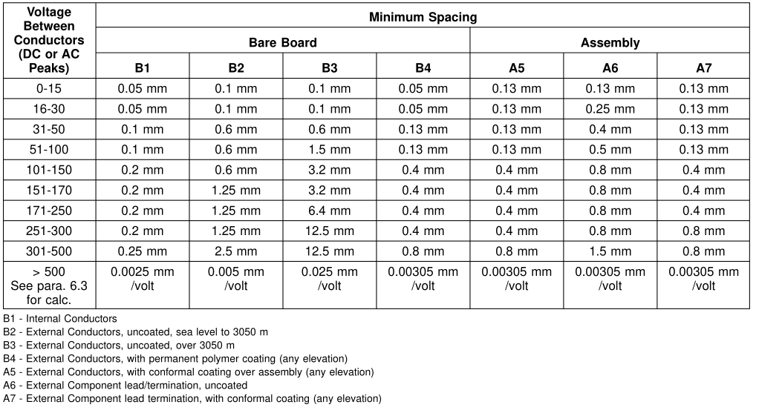

Figure 72:- Electrical Conductor Spacing [29]

|  |  |
| --- | --- |
| $$C=\left(V-500\right)*k+C_{500} \\ C=\left(2500-500\right)*0.00305+0.8 \\ C=6.1+0.8 \\ C=6.9mm$$ | $$C=\left(V-500\right)*k+C_{500} \\ C=\left(1250-500\right)*0.00305+0.8 \\ C=2.2875+0.8 \\ C=3.0875mm$$ |
| $$C=\left(V-500\right)*k+C_{500} \\ C=\left(1000-500\right)*0.00305+0.8 \\ C=1.525+0.8 \\ C=2.325mm$$ | $$C=\left(V-500\right)*k+C_{500} \\ C=\left(750-500\right)*0.00305+0.8 \\ C=0.7625+0.8 \\ C=1.5625mm$$ |

Equation 22:- Calculation for the Clearance

Table 2:- Clearance due to voltage

|  |  |  |
| --- | --- | --- |
| Voltage | Peak Voltage (V) | Clearance to Ground (mm) |
| -48 | -48 | 0.13 |
| -30 | -30 | 0.05 |
| 4 | 4 | 0.05 |
| 5 | 5 | 0.05 |
| 6.3 | 6.3 | 0.05 |
| 12 | 12 | 0.05 |
| 230RMS | 325 | 0.8 |
| 500 | 500 | 0.8 |
| 1000 | 1000 | 2.325 |
| 1250 | 1250 | 3.0875 |
| 2500 | 2500 | 6.9 |

#### PCB Trace Widths

Following the IPC-2221 standard the trace widths will be calculated with a trace width calculator online

### RF-PWR-001

Figure 73 shows the RF-PWR-001 board with planes ripped up, this shows the overall traces and then adapted into Figure 74 to be annotated for the different sections

|  |  |
| --- | --- |
| Colour | Use |
| Red | Main’s input, choke, transformer and AC/DC transformer inputs |
| Purple | 6V3 Input and rectifier, planes have been used due to currents in the plane |
| Orange | GND bases voltages output headers and DNF 4V buck converter |
| Light Green | -30V current sense IC for grid current |
| Pink | -30V input and rectifier |
| Dark Green | HV voltage divider and ADC |
| Yellow | HV transformer input and rectifier and HV bulk capacitance |
| Blue | SPI isolators |
| Brown | 6V3 current IC for plate current |

Figure 75

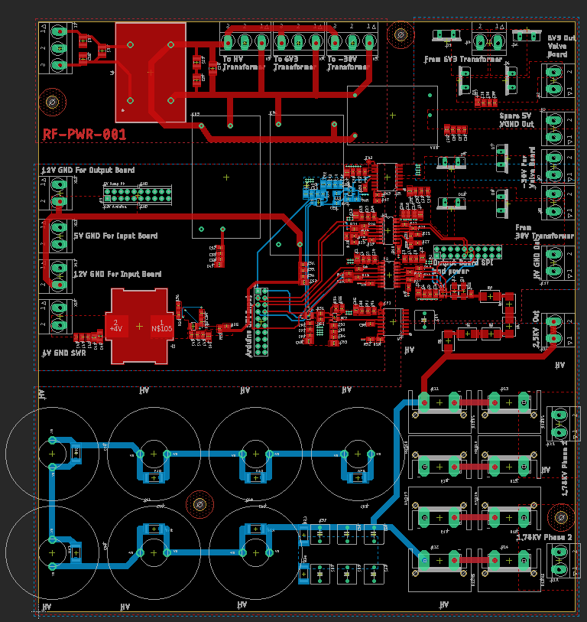

Figure 73:- RF-PWR-001 Unannotated Layout

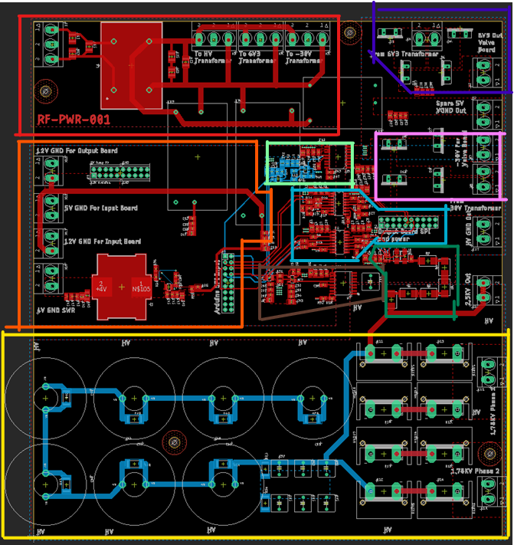

Figure 74:- RF-PWR-001 Annotated Layout

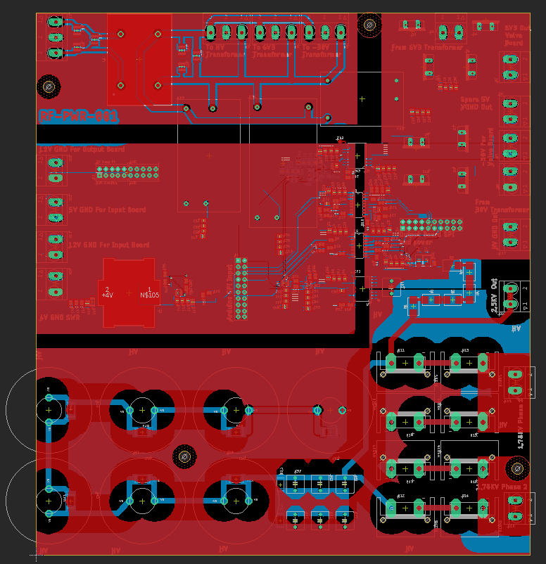

Figure 75:- RF-PWR-001 With Planes

### RF-INP-001

Figure 76 shows the basic design of the RF-INP-001 board, this was then annotated for Figure 77 which is discussed in Table 3 and Figure 78 showing the design with planes.

Table 3:- Section Purposes

|  |  |
| --- | --- |
| Section | Purpose |
| 1 | BNC output |
| 2 | Arduino GPIO header |
| 3 | 12V Relay supply Header |
| 4 | 5V PTT Supply |
| 5 | SDR SMA out and voltage |
| 6 | VNA SMA Out |
| 7 | RF input |
| 8 | Input safety relay |
| 9 | PTT connector |
| 11 | Antenna selector |
| 12 | Antenna header |
| 13 | RF output Header |
| 14 | LC filter cap 1 |
| 15 | LC filter inductors |
| 16 | LC filter cap 2 |

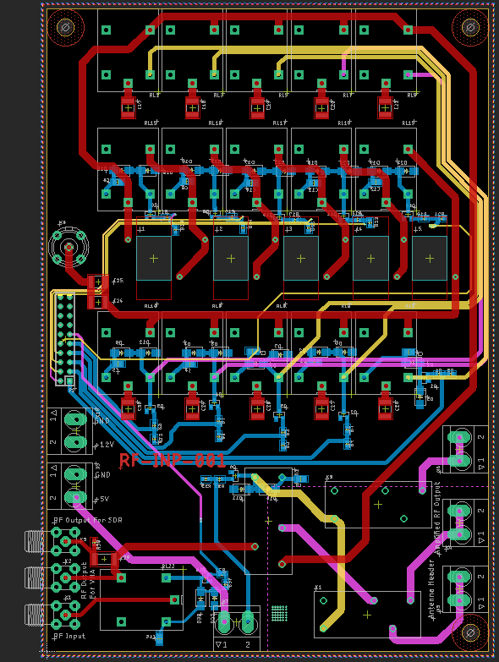

Figure 76:- RF-INP-001 Unannotated Layout

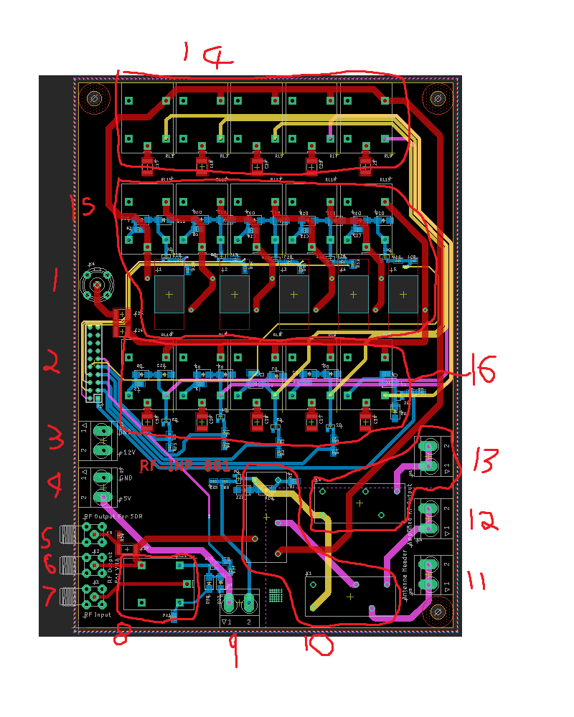

Figure 77:- RF-INP-001 Annotated

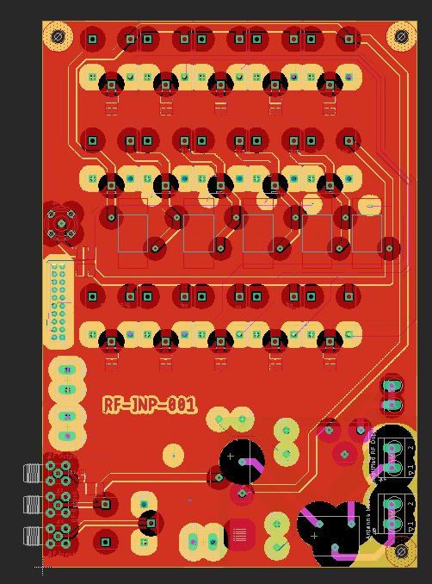

Figure 78:- RF-INP-001 With Planes

### RF-VAL-001

Figure 79 shows the valve board and Figure 80 shows the board with the planes. This board is rather sparse but the 6V3 power comes on through the bottom header, then passed through a choke, after this it is fed into the valve. On top of this the PTT and -30V are also fed on and combined then fed into the valve. The rest of the components will be external to the board connecting to the valve cap.

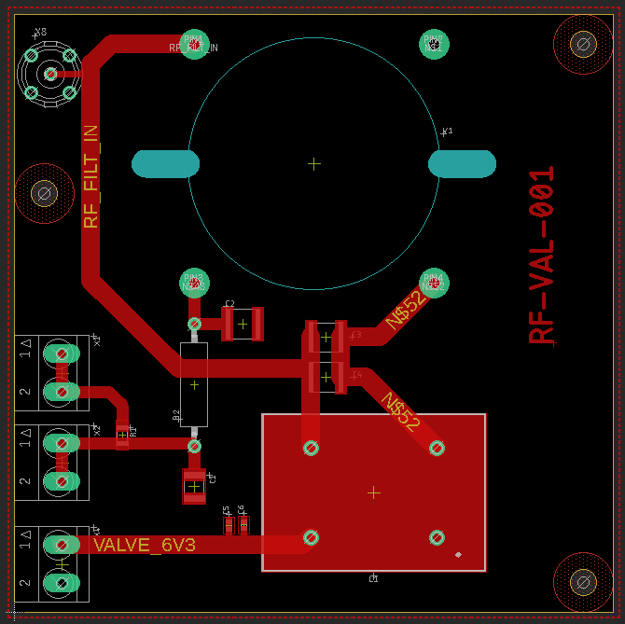

Figure 79:- RF-VAL-001 Layout

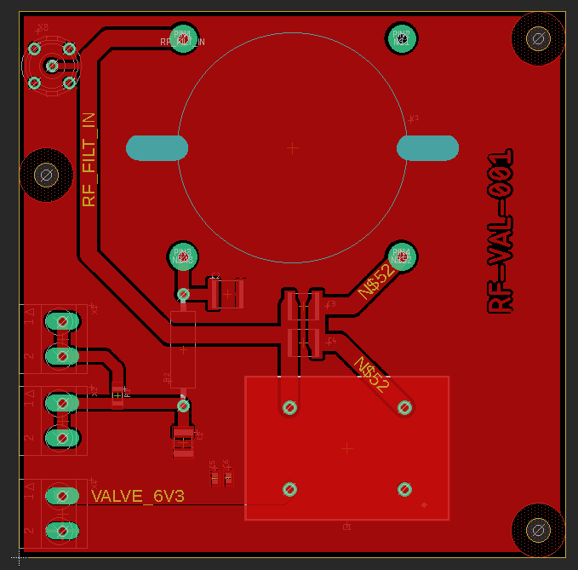

Figure 80:- RF-VAL-001 With planes

### RF-OUT-001

Figure 81 shows the RF-OUT-001 which was then annotated for Figure 82 and then planes routed for Figure 83. Table 4 shows the purpose for each section.

Table 4:- RF-OUT-001 Section Purposes

|  |  |
| --- | --- |
| Section | Purpose |
| 1 | DCR divider and SDR out |
| 2 | GPIO header |
| 3 | 12V Relay Power Header |
| 4 | SPI header |
| 5 | SWR measurement |
| 6 | SWR transformers and components |
| 7 | ATU cap 1 |
| 8 | RF input |
| 9 | ATU inductors |
| 10 | Output safety relay |
| 11 | RF output |
| 12 | ATU cap 2 |

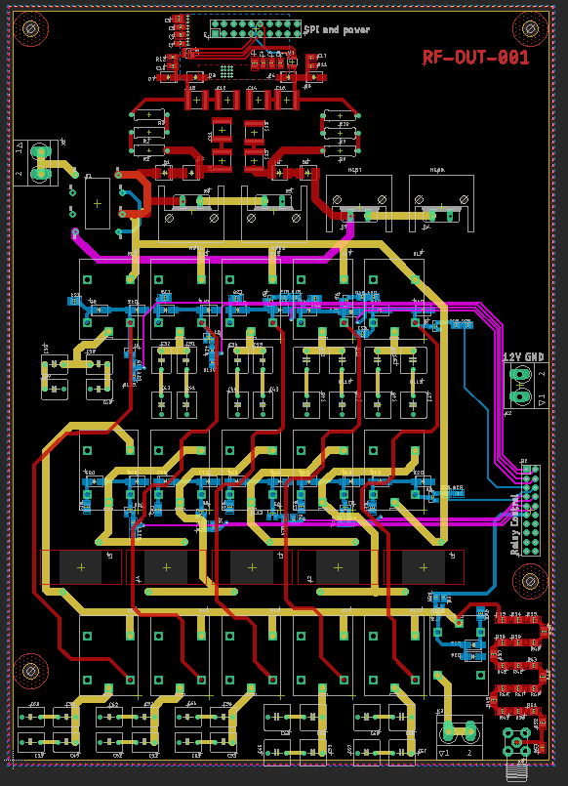

Figure 81:- RF-OUT-001 Layout

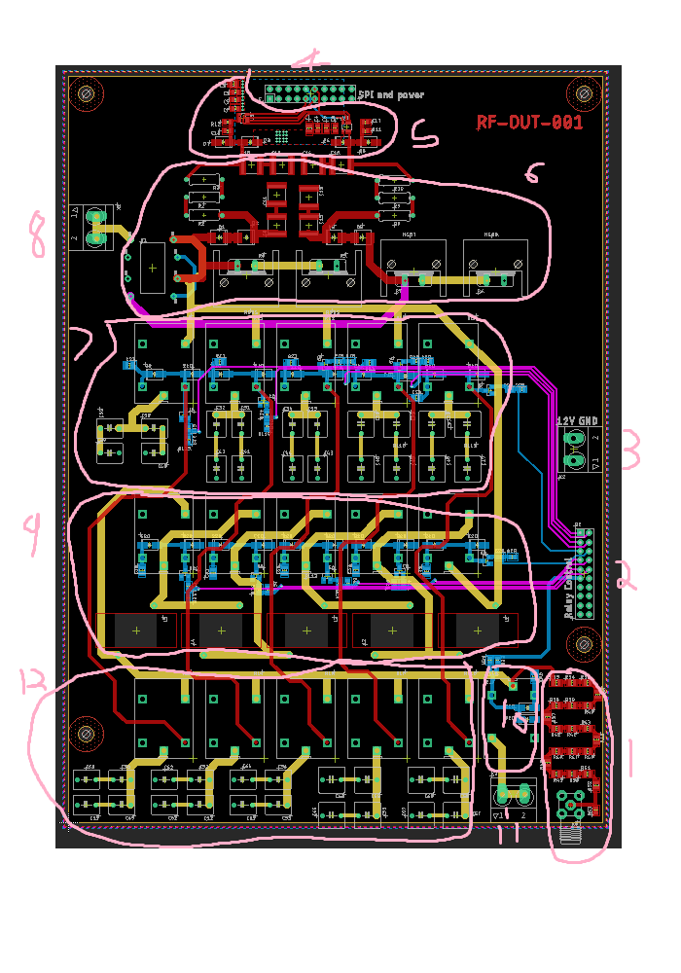

Figure 82:- RF-OUT-001 Annotated

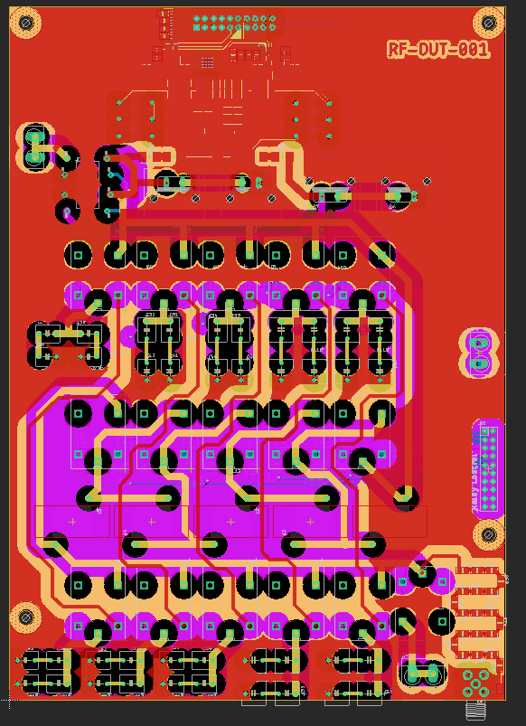

Figure 83:- RF-OUT-001 Planes

### Modular PDR

Table 5 shows the PDR carried out on the Modular design, these were all immediately carried out on the designs above.

Table 5:- Modular design PDR

|  |
| --- |
| **Change** |
| Add Silkscreen for HV Side |
| Output is moved through a loose wire not BNC |
| increase Creepage for the Output |
| Put RF on an Internal layer as its better for isolation |
| Re route the PTT |
| Bring Input X2 and X5 Silk screen on board |
| Thicken up input RF for input board to 2mm |
| Check if all pins match between boards |
| Change RF-VAL-001 input from SMA to BNC |

### Modular PDR 2

Table 6 shows the second PDR for the board, these were then changed into Table 6.

Table 6:- Modular Design PDR 2

|  |
| --- |
| **Change** |
| Add feedback of the PTT to Arduino |

Figure 84 shows the voltage divider from 5V to 3V3 for the PTT button, this showed a 4k7 and a 9k7 would get a 3-mV difference (excluding noise, tolerances and other things that will make a difference) meaning this is used. This change caused a change in RF-INP-001, Figure 85 and Figure 86 shows the schematic changes and layout changes shown in Figure 87.

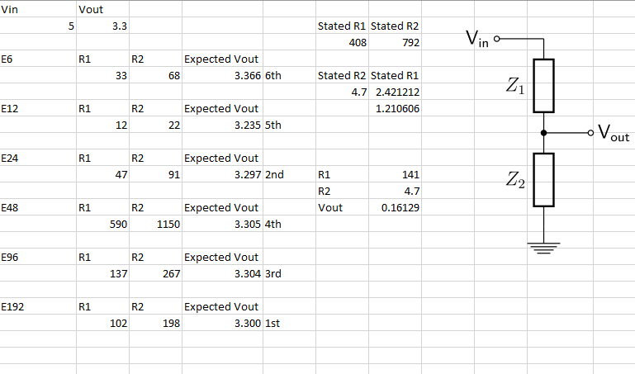

Figure 84:- Voltage Divider Simulating Excel

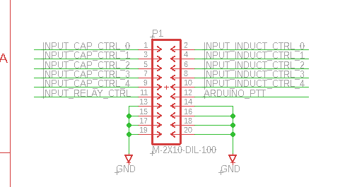

Figure 85:- New RF-INP-001 Header

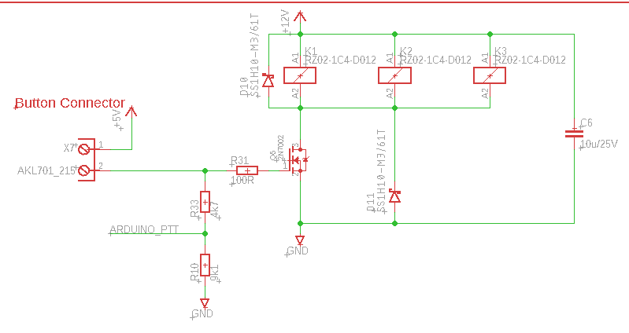

Figure 86:- New RF-INP-001 PTT

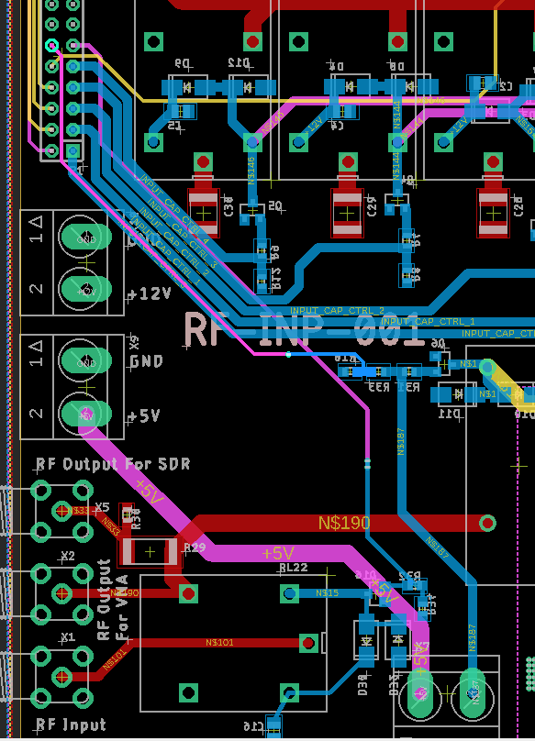

Figure 87:- Adapted Layout Section

### BOM

The Bom was then reviewed to check the BOMS for the different boards in Figure 88 for RF-PWR-001 which costs £256.84 total, Figure 89 for RF-INP-001 which costs £55.27, Figure 90 for RF-VAL-001 which costs £76.37, Figure 91 for RF-OUT-001 which costs £76.37 and finally Figure 92 for the external components which totals £297.53. The price breakdowns are shown in Figure 93, Figure 94, Figure 95, Figure 96 and Figure 97 in the same order

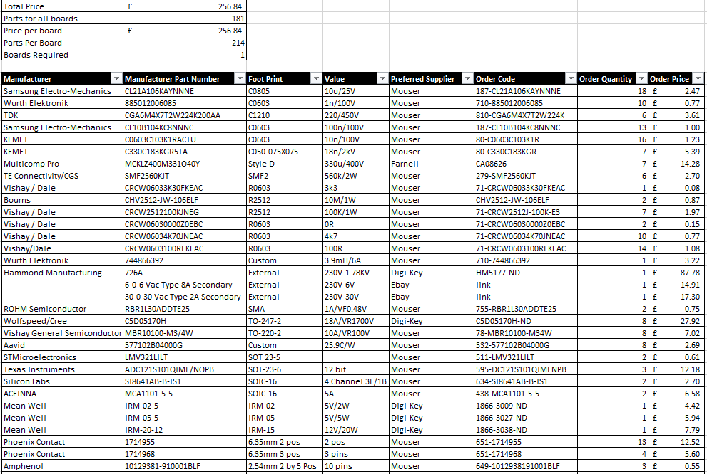

Figure 88:- RF-PWR-001 BOM



Figure 89:- RF-INP-001 BOM

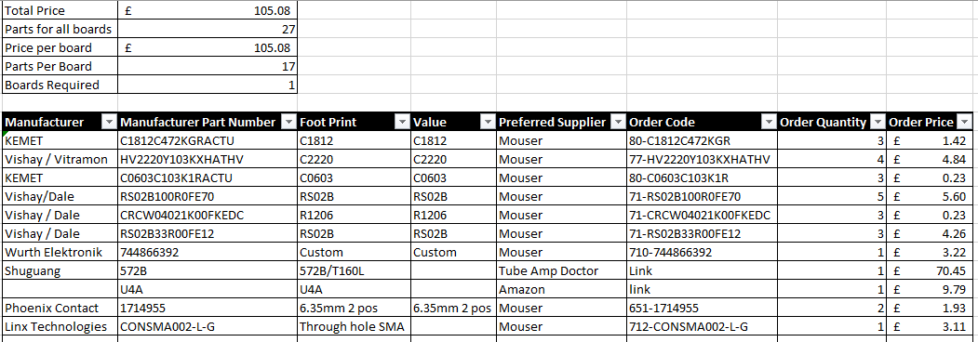

Figure 90:- RF-VAl-001 BOM



Figure 91:- RF-OUT-001 BOM

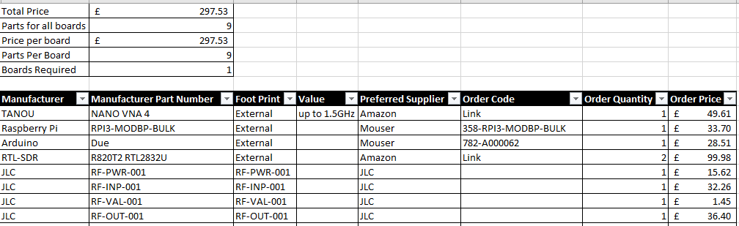

Figure 92:- RF-EXTRN-001 BOM

Figure 93:- RF-PWR-001 BOM Breakdown

Figure 94:- RF-INP-001 BOM Breakdown

Figure 95:- RF-VAL-001 BOM Breakdown

Figure 96:- RF-OUT-001 BOM Breakdown

Figure 97:- RF-EXTRN-001 BOM Breakdown

## CDR

The CDR was then carried out, the boards will be made on a FR-4 1oz, 2- or 4-layer PCB made by JLC. The designs were also revied with Matthew Love and another engineer at Mage Control Systems. Everything will be made using standard DR-4 manufacturing then hand soldering for components. All components will be ordered before ordering the PCBs and equivalents found for any out of stock.

## Operation

The amplifier has several operating modes, depending on what its current task, these are tasks are Receiving, Transmitting, Filter Switch and Fault controlled by a web UI on the Rasp Pi.

### Receiving Mode

It is in this mode when the PTT button is not pressed.

The antenna and the RF input would be directly connected and safety relay being closed.

Filters would be held in position to start transmitting at a moment’s notice.

HV voltage constantly measured faults

Grid and plate currents monitored for faults

Any faults found then move to faults.

basic communication between Raspberry Pi and Arduino checking both are active and any changes in operating frequency

Raspberry Pi would not be check SDRs.

### Transmitting Mode

Started by the PTT button being pressed.

Antenna connected to output RF Input connected to the filter and thus amplifier

safety relay closed.

amplifying started

HV voltage, grid current, plate current and SWR monitored for fault

Raspberry Pi live monitor the SDRs looking for any major distortion.

### Filter Switch Mode

There is two version of the Filter Switch Mode.

#### Filter Switching (Receiving)

Command to switch filter comes in from the Raspberry Pi

If PTT button not pressed

previous filter would be disconnected, and new filter switched in simultaneously.

This would be done on both the Input and Output Boards at the same time.

#### Filter Switching (Transmitting)

When the command to switch filter comes in from the Raspberry Pi

If PTT button pressed

Input safety relays would be disconnected

short time delay

output relay would be disconnected

short delay

previous filter would be disconnected, and new filter switched in simultaneously.

short delay

safety relays close

Delays and disconnected needed for relays to close and preventing SWR Spikes which could cause damage.

### Fault Mode

fault detected

Both safety relays immediately disconnected

error message sent to the user vis pi.

### Web UI

A basic web UI will be added hosted on the Raspberry Pi. This will have live data to be monitored about the SWR, the voltages and currents.

Extension to live monitoring of SDRs may be added too.

The Web Ui would allow transmitting frequency to be set. Which would be passed onto the Arduino.

During warning or fault conditions alerts would be pushed to user to notify them.

### Arduino Pseudo Code

The Arduino start up Pseudo code is shown in Code 1, this shows how the Arduino would operate and connect to the other pseudo codes here. This is a basic overview of how it would be coded once the project had had got to that stage.

Code 1:- Start Up Pseudo Code

|  |
| --- |
| Initialise UART to Raspberry Pi Set up threshold variables Set up other variables Wait for configuration data from Raspberry pi. Extract Filter Mode if PTT has been pressed  <Go to transFiltSwitch (Code 4)> else  <Go to normFiltSwitch (Code 5)> <Go to main Loop (Code 2)> |

Code 2:- Main Loop Pseudo Code

|  |
| --- |
| While true  Report readings to Raspberry Pi  Check for new messages from Raspberry Pi  if Raspberry Pi Timeout  <go to fault (Code 3)>  if Fault Reported   <go to fault (Code 3)>  if filter mode change  if PTT has been pressed  <Go to transFiltSwitch (Code 4)>  else  <Go to normFiltSwitch (Code 5)>  Check HV Voltage  If Volt fault found  <go to fault (Code 3)>  Check Plate Current  If Plate fault found  <go to fault (Code 3)>  Check Grid Current  If Grid fault found  <go to fault (Code 3)>  Check SWR ADC  Calculate SWR  If SWR fault found  <go to fault (Code 3)> |

Code 3:- Fault Pseudo Code

|  |
| --- |
| Disconnect Safety Relays Delay relay time Disconnect Filter Relays Delay relay time Wait for resume from raspberry pi <Go to transFiltSwitch (Code 4)> Return to main Loop |

Code 4:- transFiltSwitch Pseudo Code

|  |
| --- |
| Disconnect input Safety Relay Delay relay time Disconnect output Safety Relay Delay relay time Change Filter Relays to new mode Delay relay time Reconnect input Safety Relay Delay relay time Reconnect output Safety Relay Delay relay time Return |

Code 5:- normFiltSwitch Pseudo Code

|  |
| --- |
| Change Filter Relays to new mode Return |

## RF Propagation

The density of a forest depends on multiple factors but a guide on US forests is shown in Figure 98

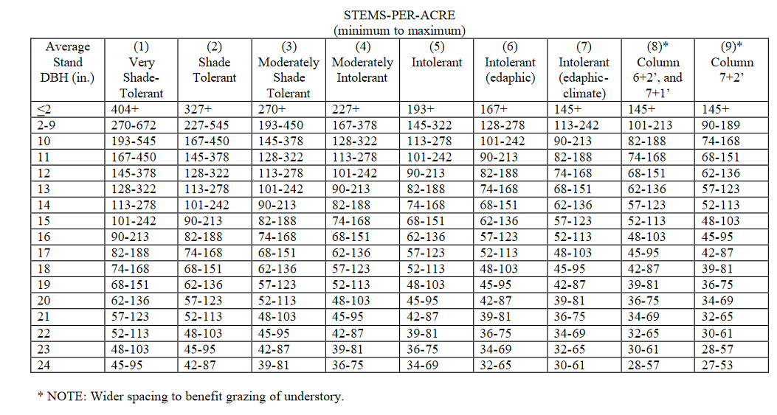

Figure 98:- Density of a Forest based on DBH and Shade Tolerance [30]

The equipment for this experiment is shown in Table 7, with photos of it in Figure 99 and Figure 100.

Table 7:- Part Numbers for Equipment

|  |  |  |
| --- | --- | --- |
| Equipment | Manufacturer | Part Number |
| Signal Generator | RIGOL | DG832 |
| Spectrum Analyser | RIGOL | RSA3030-TG |
| Antenna | Custom | 1 m long unshielded cable |

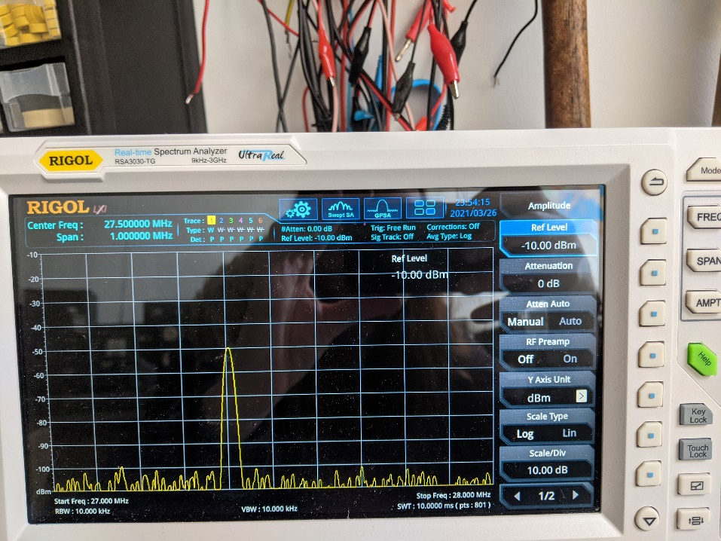

Figure 99:- Spectrum Analyser for the RF propagation

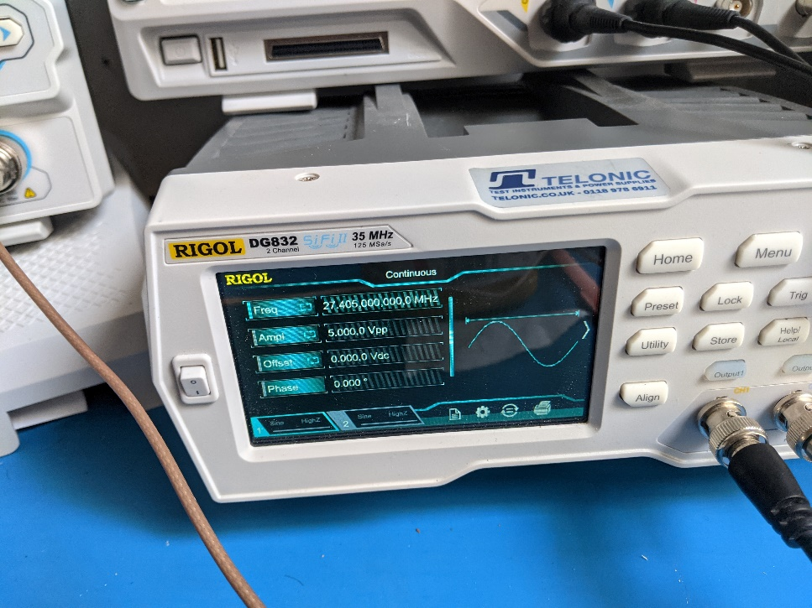

Figure 100:- Signal generator for the RF Propagation

How the experiment was done

1. Set up signal gen for 1.841 MHz and pass it out to an antenna in the hedge.
2. Set up spectrum analyser for frequency and attach antenna in the hedge.
3. Measure distance between antennas
4. Take screenshot on analyser of result
5. Repeat 3 and 4 for multiple distances increasing distance
6. Repeat from 1 using 27.405 MHz
7. Repeat from 1 but with antennas outside hedge

### Results

First information on the hedge was found in Table 8 and Table 9. And the results were extracted and shown in Table 10, Table 11, Table 12 and Table 13. This data was then adapted into the graph shown in Figure 101 for 1.8410 MHz and then Figure 102 for 27.405 MHz, this was then analysed, the 1.8410 MHz out of the hedge 13.92 m distance result was then removed as it is a major outlier, this created the graph in Figure 103, this shows that outside the hedge that the rate the attenuation decreases is faster but it has an offset of around 11 dBm at the start, it is likely this is due to the attenuation of the in hedge result being lower which in turn means that the rate of decrease is much lower. This was the repeated for 27.405 MHz in Figure 104, this shows almost no difference between the two results and with the hedge within margin of error at the start and outside it is faring slightly better in the long run. This in general is acceptable. This suggests over all the loss is nearly negligible and within margin of error.

Table 8:- Stalks per acre

|  |  |  |  |  |  |  |
| --- | --- | --- | --- | --- | --- | --- |
| Reading | Width (m) | Length (m) | Stalk Number | Area (m^2) | Stalks per m^2 | Stalks per acre |
| 1 | 0.5 | 2.58 | 24 | 1.29 | 18.6 | 75290.4 |
| 2 | 0.7 | 2.16 | 52 | 1.512 | 34.4 | 139177.6 |
| 3 | 1.7 | 2 | 30 | 3.4 | 8.8 | 35707.6 |
| Average |  |  |  |  | 20.6 | 83391.8 |

Table 9:- Diameter at Breast Height of the Hedge

|  |  |  |
| --- | --- | --- |
| Reading | DBH (mm) | DBH (in) |
| 1 | 25 | 1.0 |
| 2 | 35 | 1.4 |
| 3 | 32 | 1.3 |
| 4 | 30 | 1.2 |
| 5 | 25 | 1.0 |
| Average | 29.4 | 1.2 |

Table 10:- 1.8410 MHz In Hedge Results

|  |  |  |
| --- | --- | --- |
| Distance (m) | Attenuation dBm | Appendix |
| 0 | -85.4 | Figure 105 |
| 1.8 | -85.4 | Figure 106 |
| 4.1 | -86 | Figure 107 |
| 5.9 | -86 | Figure 108 |
| 8.1 | -87.2 | Figure 109 |
| 12.1 | -89.6 | Figure 110 |
| 17.2 | -89 | Figure 111 |

Table 11:- 27.405 MHz In Hedge Results

|  |  |  |
| --- | --- | --- |
| Distance (m) | Attenuation dBm | Appendix |
| 0 | -40 | Figure 112 |
| 2.1 | -42 | Figure 113 |
| 4.2 | -50 | Figure 114 |
| 7.75 | -50 | Figure 115 |
| 9.22 | -50.1 | Figure 116 |
| 10.44 | -50.5 | Figure 117 |
| 13.92 | -54 | Figure 118 |
| 17.02 | -56 | Figure 119 |

Table 12:- 1.8410 MHz out of Hedge Results

|  |  |  |
| --- | --- | --- |
| Distance (m) | Attenuation dBm | Appendix |
| 0 | -74.8 | Figure 120 |
| 2.1 | -74.8 | Figure 121 |
| 4.2 | -74.4 | Figure 122 |
| 7.75 | -79.2 | Figure 123 |
| 9.22 | -79.2 | Figure 124 |
| 10.44 | -79.2 | Figure 125 |
| 13.92 | -88.4 | Figure 126 |

Table 13:- 27.405 MHz out of Hedge Results

|  |  |  |
| --- | --- | --- |
| Distance (m) | Attenuation dBm | Appendix |
| 0 | -42 | Figure 127 |
| 1.1 | -44 | Figure 128 |
| 3.35 | -46 | Figure 129 |
| 5.1 | -46 | Figure 130 |
| 7.2 | -46 | Figure 131 |
| 10.5 | -48 | Figure 132 |
| 12.4 | -54 | Figure 133 |

### Results analysed

The results are then graphed into Figure 101 and Figure 102

Figure 101:- 1.8410 MHz Attenuation Comparison

Figure 102:- 27.405 MHz Attenuation Comparison

Figure 103:- RF Propagation with lines of best fit 1.8410 MHz

Figure 104:- RF Propagation with lines of best fit 27.405 MHz

### Conclusion

The hedge had minimal effect on the signal. But the hedge did affect the attenuation for the 1.8410 MHz as could be seen in the graphs whereas it affected the higher frequency 27.405 MHz much less. This suggests for the CB band around 27.405 MHz that the affect is almost negligible, but for 1.8410 MHz the affect is major over short distances. Overall, this is promising for 27.410 MHz as this suggests that transmission on this frequency is possible.

This experiment has an issue with the RF signal possibly exiting the side of the hedge and propagate round to back in later, however this would be possible in a forest through its canopy, and this would have been more pronounced in the 1.8410 MHz signal than the 27.410 MHz, but a difference there was seen. However overall, there is a suggestion that there is minimal affect.

### Results Photos

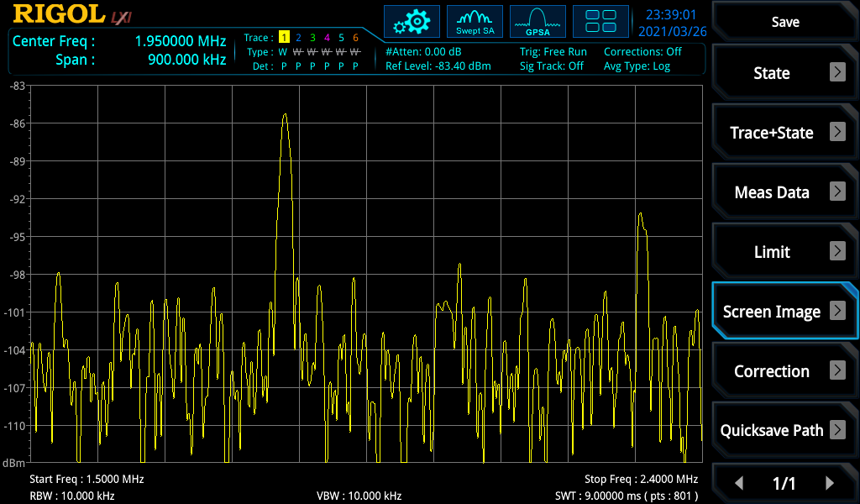

Figure 105:- 1.8410 MHz at 0 m in Hedge

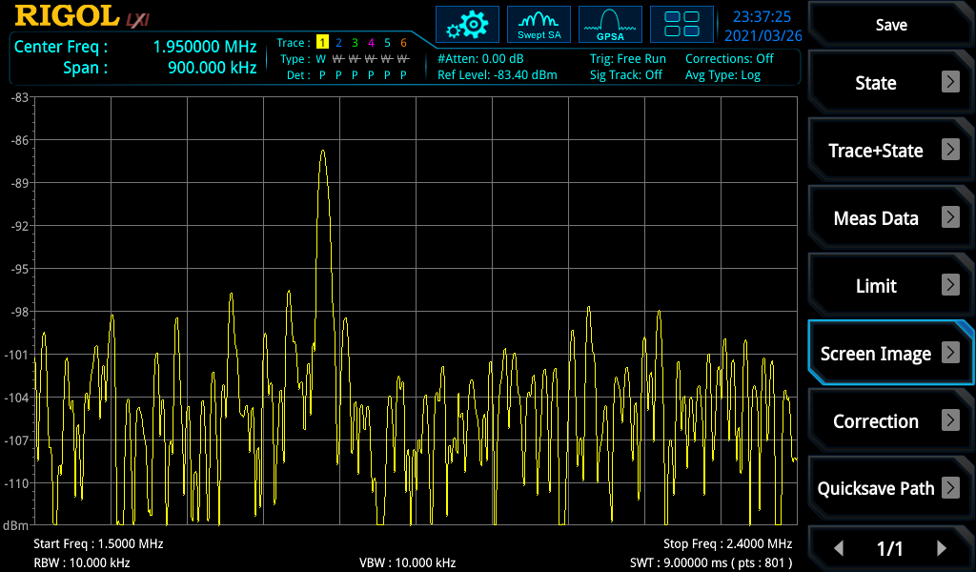

Figure 106:- 1.8410 MHz at 1.8 m in Hedge

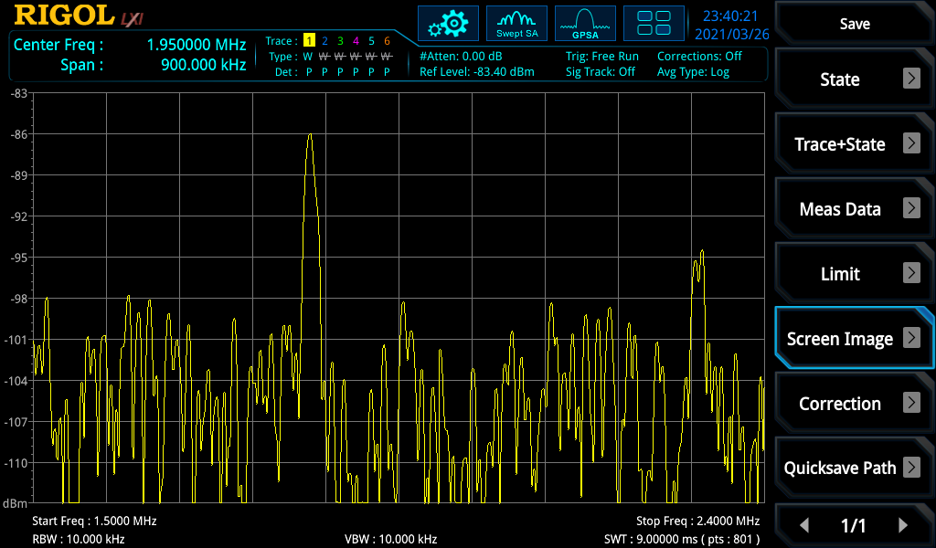

Figure 107:- 1.8410 MHz at 4.1 m in Hedge

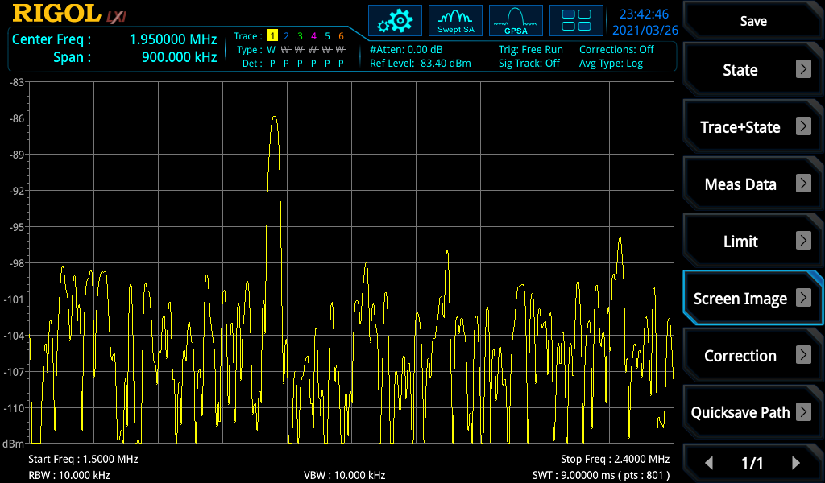

Figure 108:- 1.8410 MHz at 5.9 m in Hedge

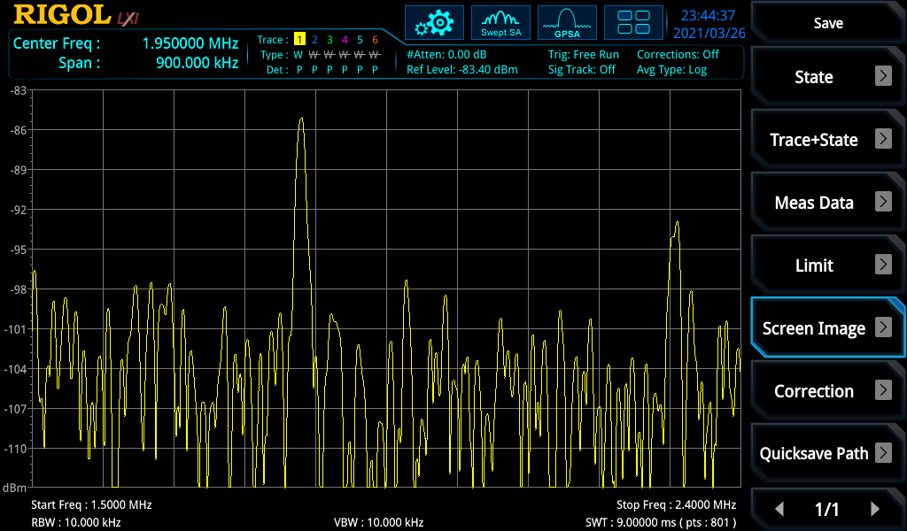

Figure 109:- 1.8410 MHz at 8.1 m in Hedge

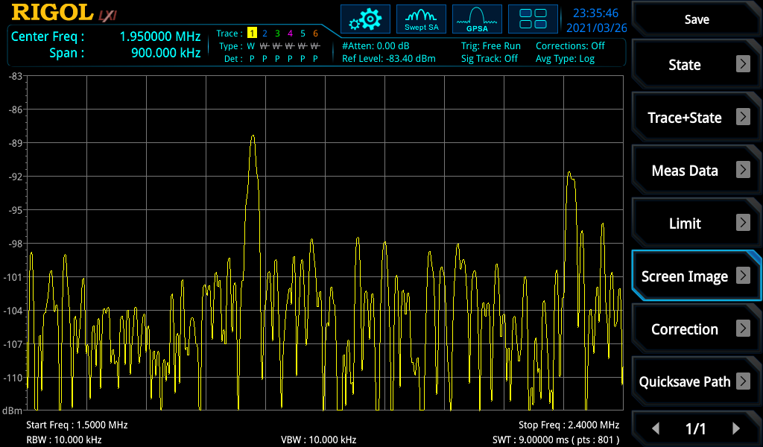

Figure 110:- 1.8410 MHz at 12.1 m in Hedge

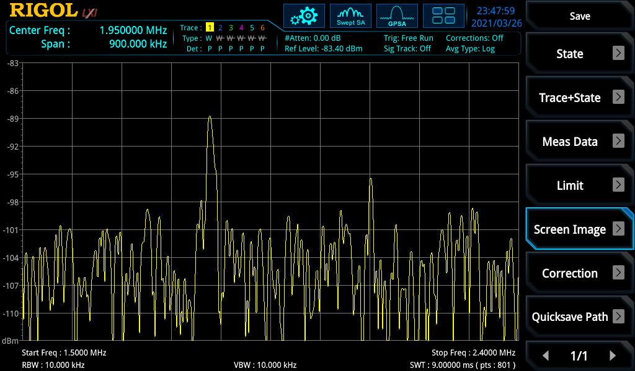

Figure 111:- 1.8410 MHz at 17.2 m in Hedge

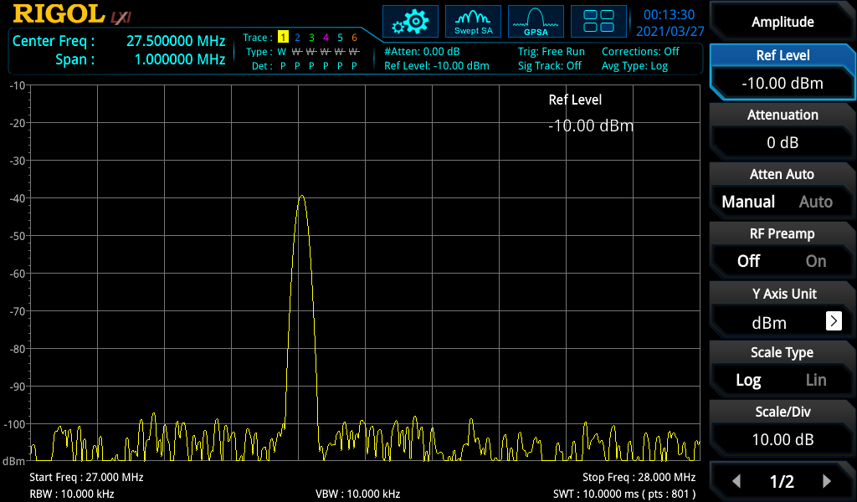

Figure 112:- 27.405 MHz at 0 m in Hedge

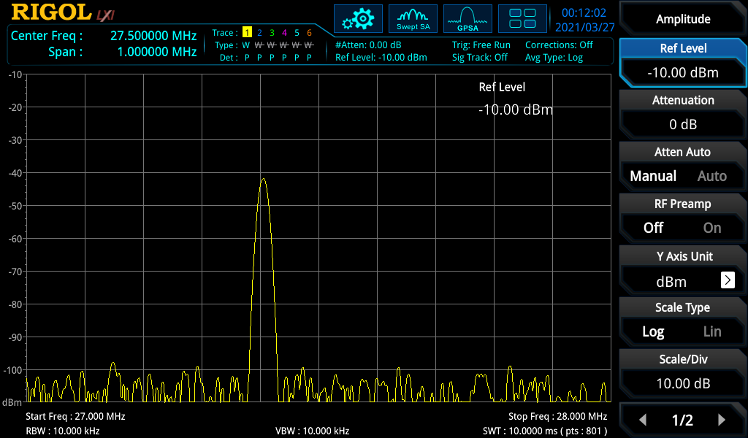

Figure 113:- 27.405 MHz at 2.1 m in Hedge

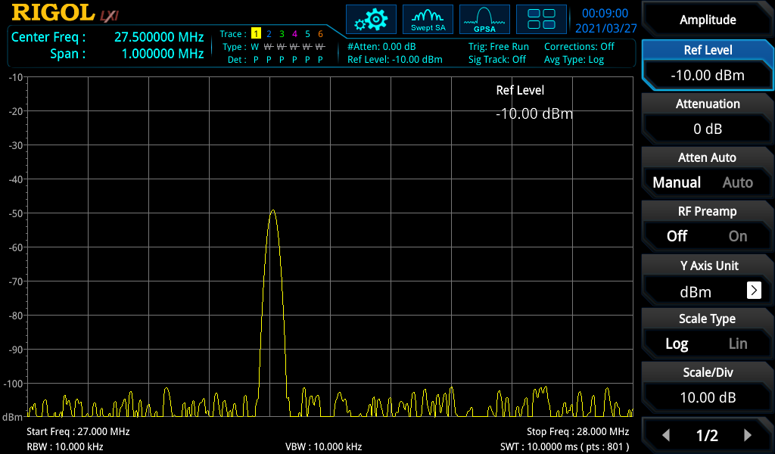

Figure 114:- 27.405 MHz at 4.2 m in Hedge

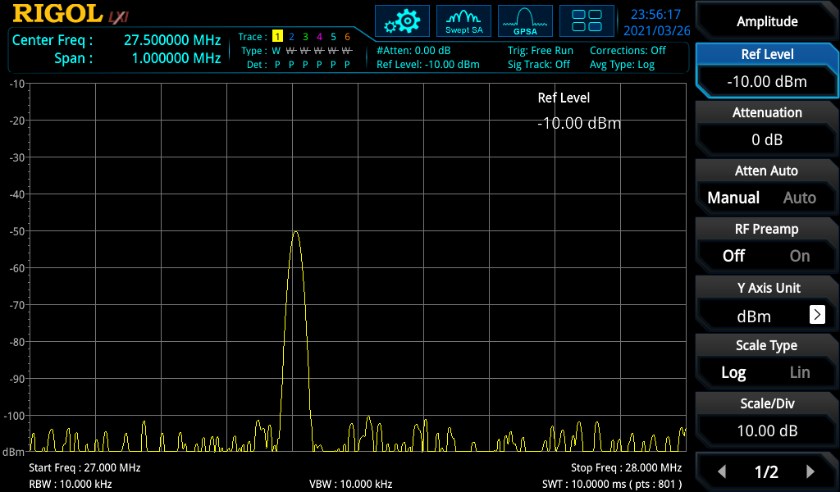

Figure 115:- 27.405 MHz at 7.75 m in Hedge

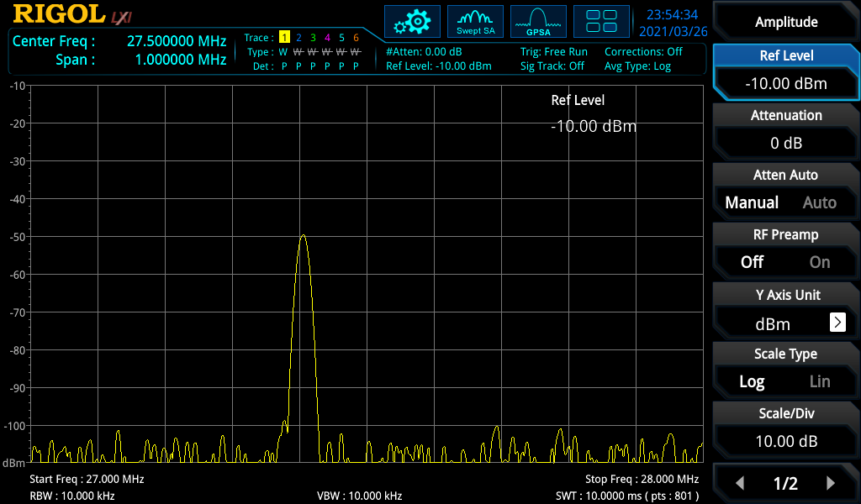

Figure 116:- 27.405 MHz at 9.22 m in Hedge

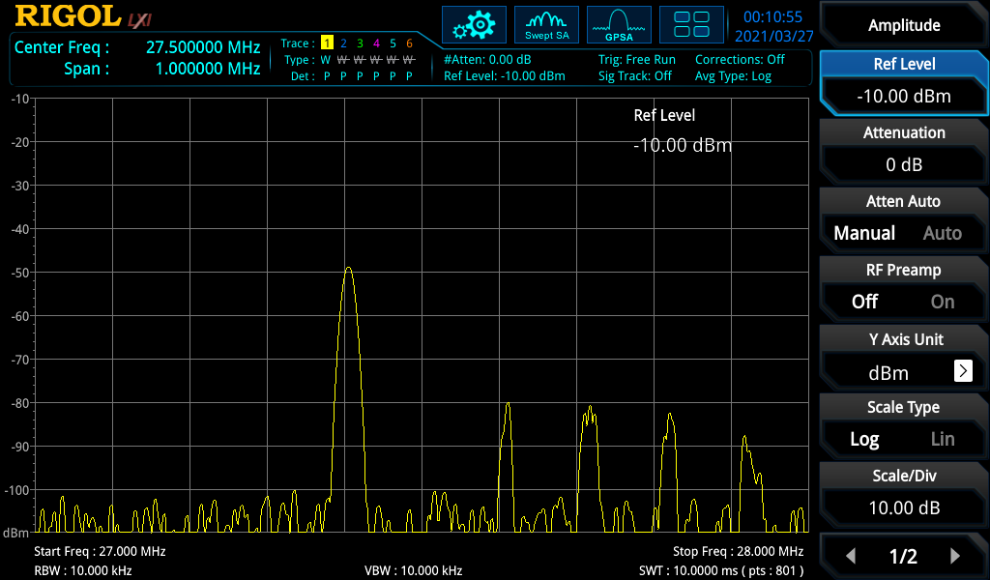

Figure 117:- 27.405 MHz at 10.44 m in Hedge

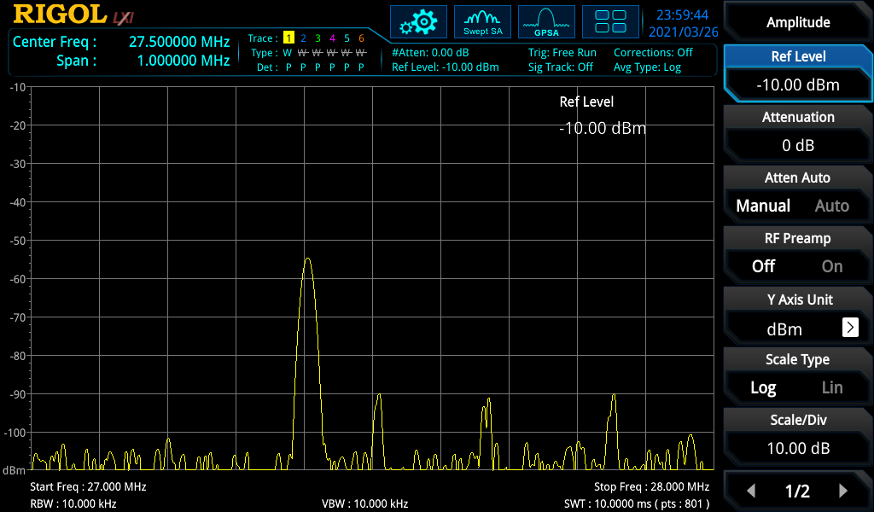

Figure 118:- 27.405 MHz at 13.92 m in Hedge

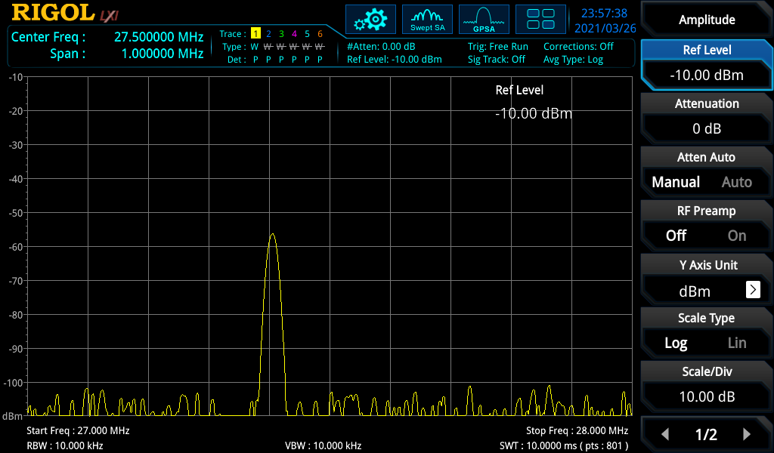

Figure 119:- 27.405 MHz at 17.02 m in Hedge

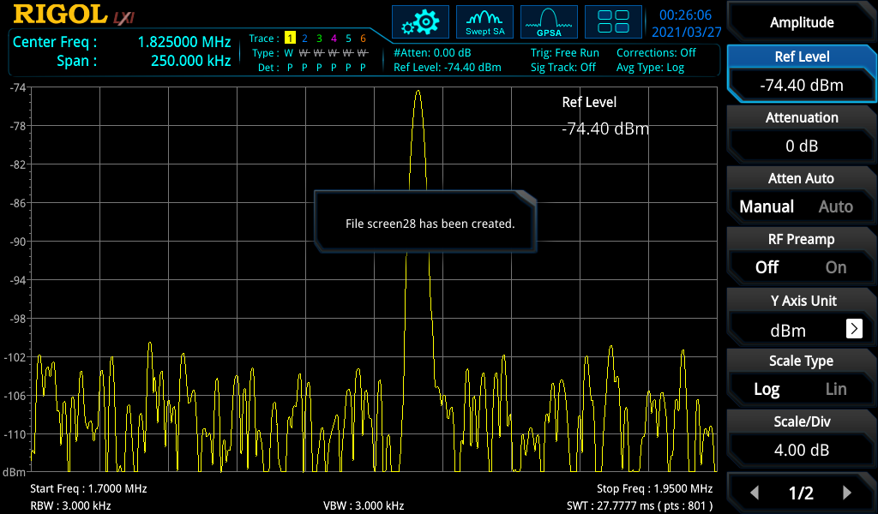

Figure 120:- 1.8410 MHz at 0 m in Hedge

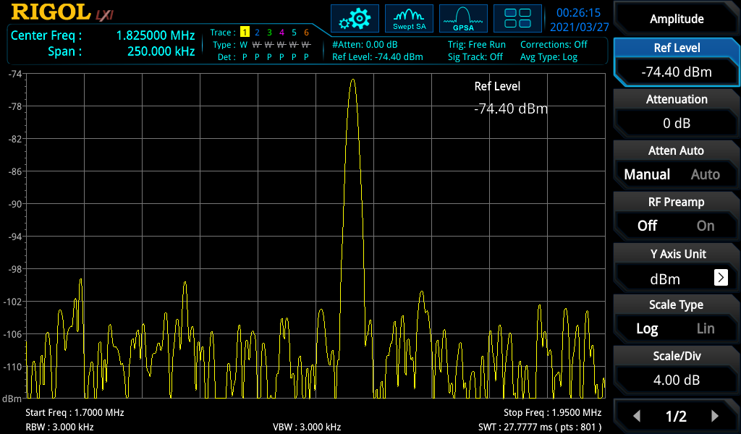

Figure 121:- 1.8410 MHz at 1.1 m in Hedge

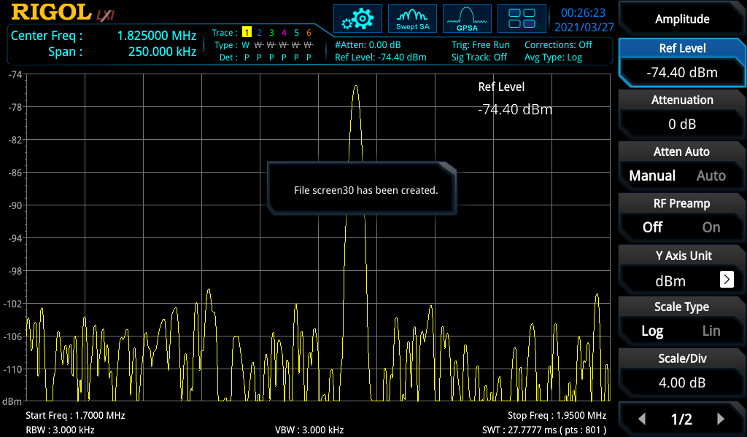

Figure 122:- 1.8410 MHz at 3.35 m in Hedge

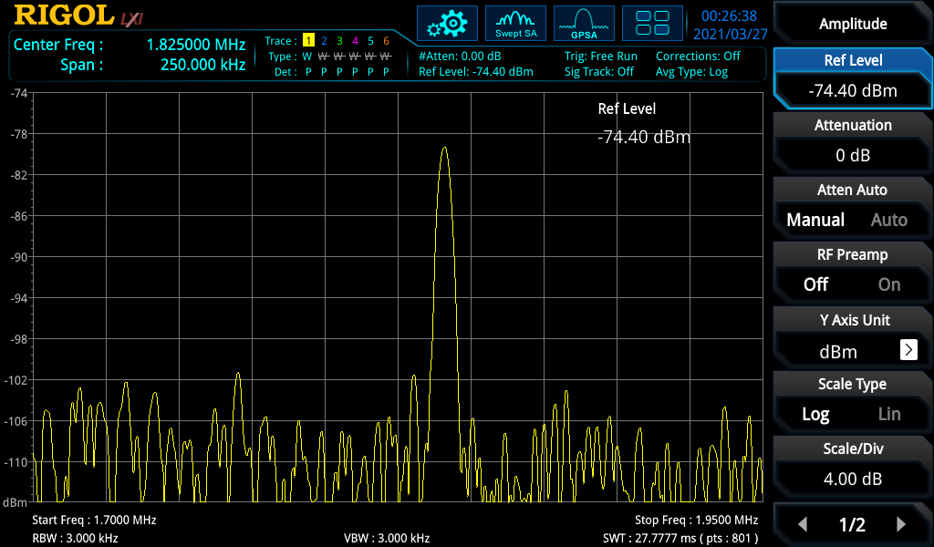

Figure 123:- 1.8410 MHz at 5.1 m in Hedge

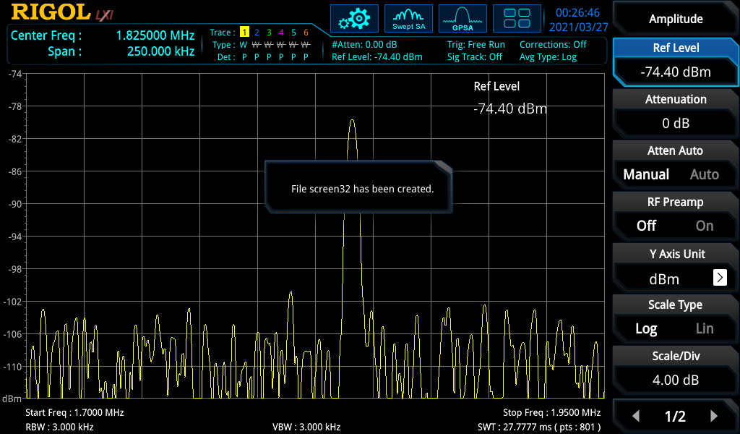

Figure 124:- 1.8410 MHz at 7.2 m in Hedge

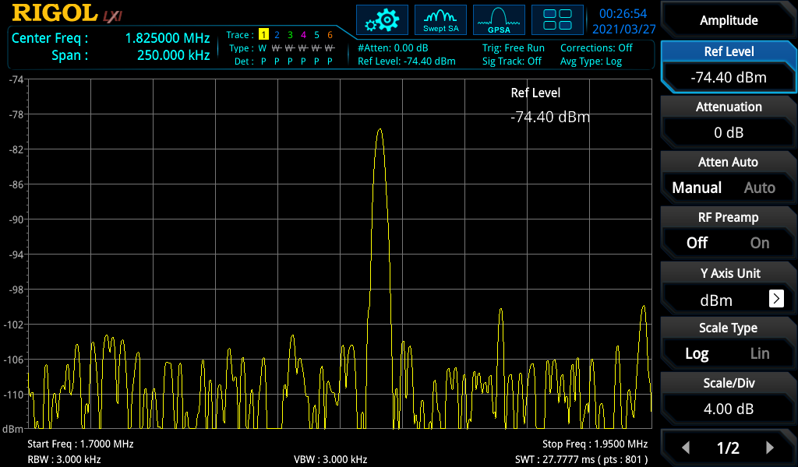

Figure 125:- 1.8410 MHz at 10.5 m in Hedge

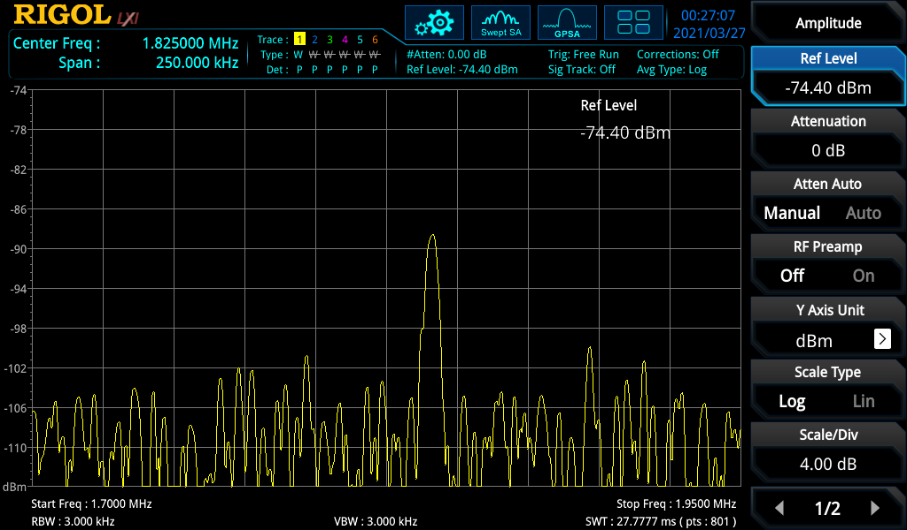

Figure 126:- 1.8410 MHz at 12.4 m in Hedge

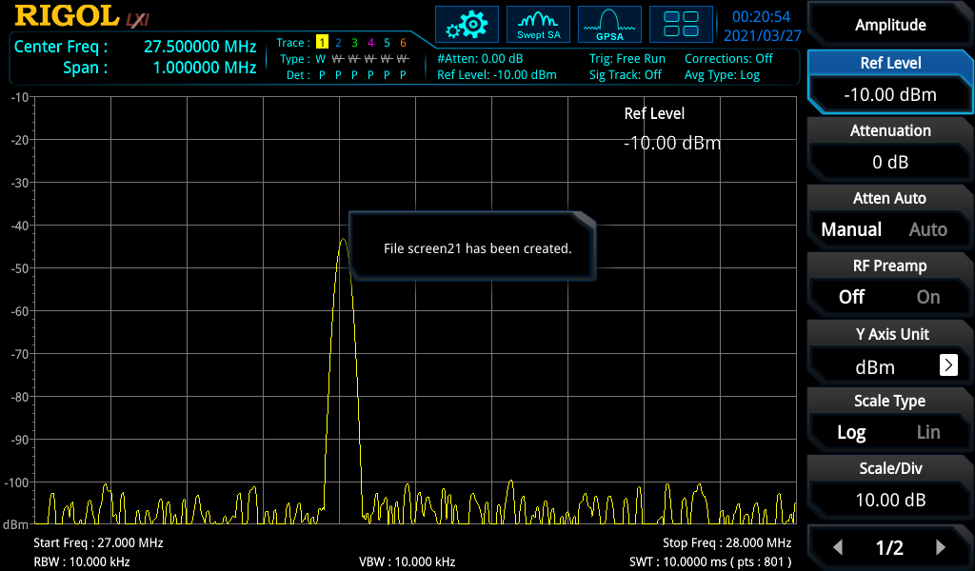

Figure 127:- 27.405 MHz at 0 m in Hedge

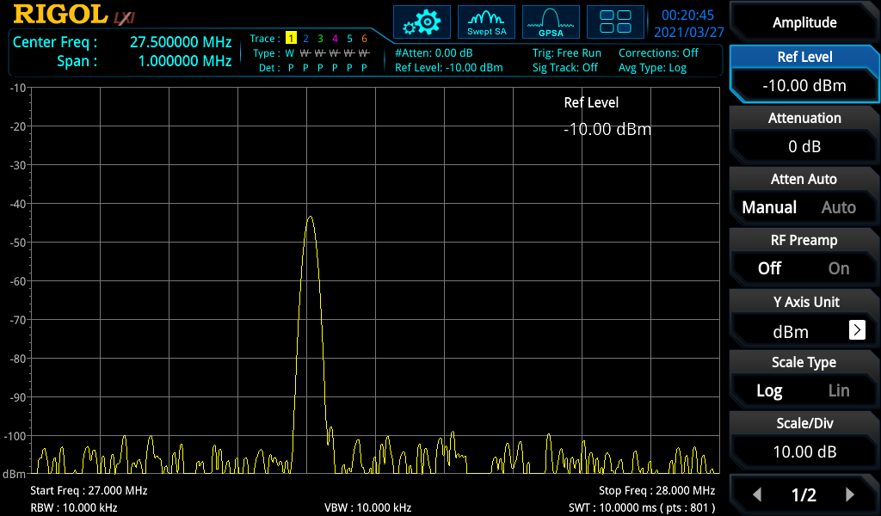

Figure 128:- 27.405 MHz at 1.1 m in Hedge

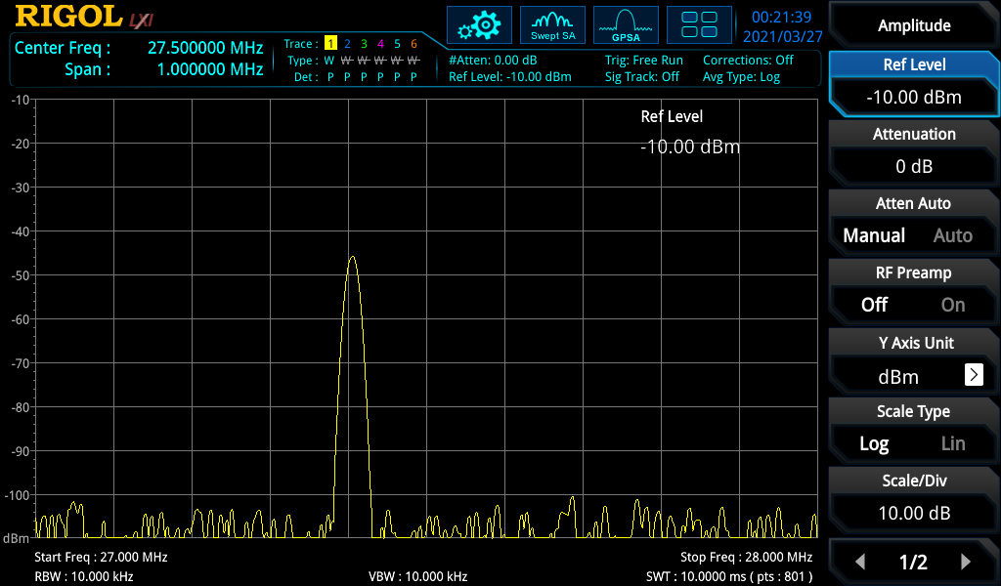

Figure 129:- 27.405 MHz at 3.35 m in Hedge

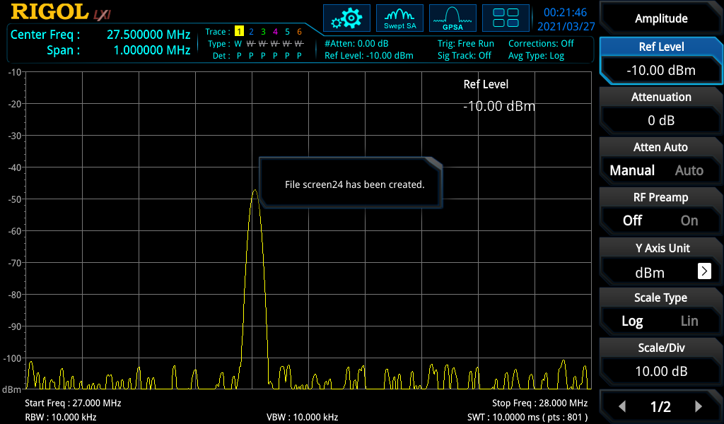

Figure 130:- 27.405 MHz at 5.1 m in Hedge

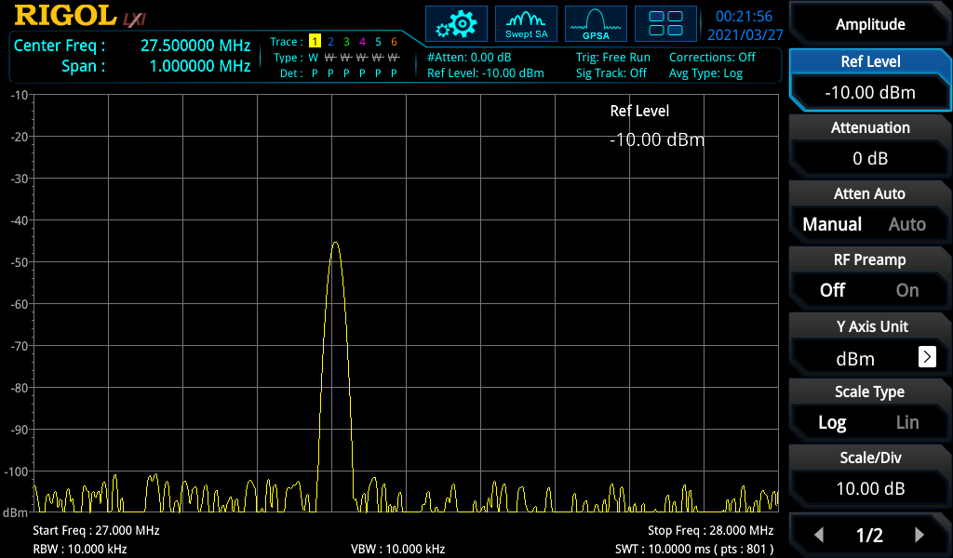

Figure 131:- 27.405 MHz at 7.2m in Hedge

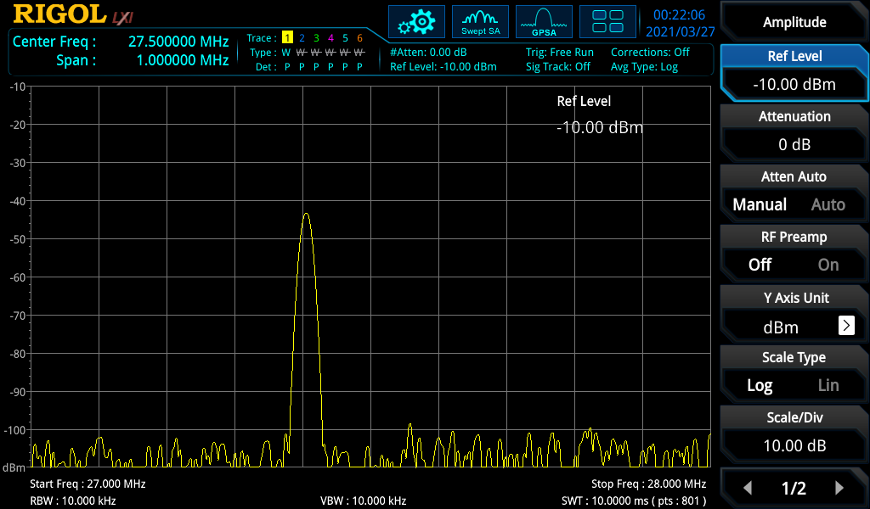

Figure 132:- 27.405 MHz at 10.5 m in Hedge

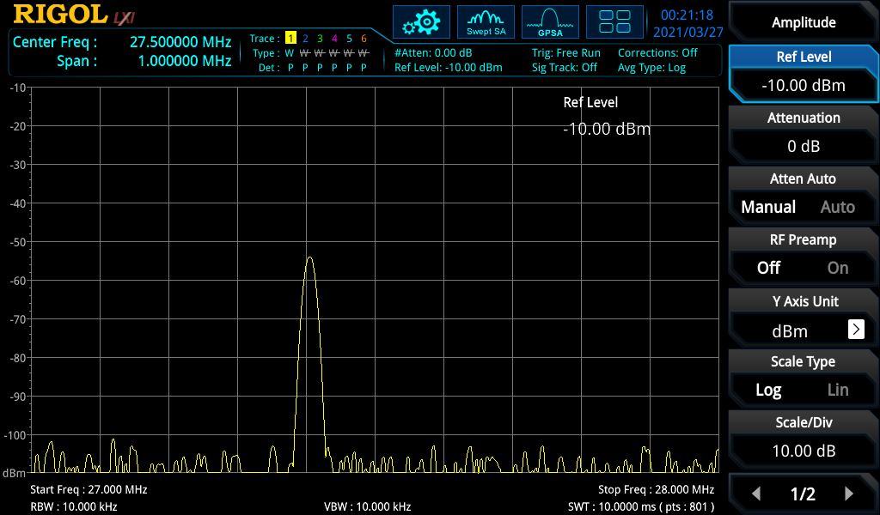

Figure 133:- 27.405 MHz at m 12.4 in Hedge

# References

|  |  |
| --- | --- |
| [1] | S. Gupta, “Classes of Power Amplifiers,” Circuit Digest, 11 December 2018. [Online]. Available: https://circuitdigest.com/tutorial/classes-of-power-amplifier-explained. [Accessed 8 December 2020]. |
| [2] | R. Symons, “Tubes: Still Vital after all these years,” 4 April 1998. [Online]. Available: https://ieeexplore.ieee.org/document/666962. |
| [3] | D. L. William, “What is a Linear Amplifier,” HAM'S Life, 23 July 2012. [Online]. Available: http://www.hamslife.com/what-is-a-linear-amplifier/. [Accessed 8 December 2020]. |
| [4] | Techopedia, “Radio Propagation,” Techopedia, [Online]. Available: https://www.techopedia.com/definition/9077/radio-propagation. [Accessed 24th March 2021]. |
| [5] | Math Open Reference, “Normal,” Math Open Reference, 2011. [Online]. Available: https://www.mathopenref.com/normal.html. [Accessed 24th March 2021]. |
| [6] | H. Wen-Yu, S. Ying, Y. Mudan and H. Lin, “Creating in-plane pseudomagnetic fields in excess of 1000 T by misoriented stacking in a graphene bilaye,” Department of Physics, Beijing Normal University, Beijing, 100875, People’s Republic of China, March 2014. [Online]. Available: https://www.researchgate.net/figure/color-online-The-curved-surface-represents-a-strained-graphene-sheet-We-can_fig1_260628831. [Accessed 24th March 2021]. |
| [7] | Fizik, “Reflection of waves,” Fizik , 22nd December 2010. [Online]. Available: http://fizik-fizik.blogspot.com/2010/12/reflection-of-waves.html. [Accessed 24th March 2021]. |
| [8] | The Physics Classroom, “Reflection of a Pulse at a Fixed End,” The Physics Classroom, [Online]. Available: https://www.physicsclassroom.com/mmedia/waves/fix.cfm. [Accessed 24th March 2021]. |
| [9] | The Physics Classroom, “ Reflection of a Pulse at a Free End,” The Physics Classroom, [Online]. Available: https://www.physicsclassroom.com/mmedia/waves/free.cfm. [Accessed 24th March 2021]. |
| [10] | Wave Behaviour RAFT, “Reflection,” Wave Behaviour RAFT, [Online]. Available: https://sites.google.com/site/wavebehaviourraft/reflection. [Accessed 24th March 2021]. |
| [11] | Science Learning Hub, “Refraction of light,” Science Learning Hub, 23rd May 2020. [Online]. Available: https://www.sciencelearn.org.nz/resources/49-refraction-of-light. [Accessed 24th March 2021]. |
| [12] | PhysicsNet.co.uk, “Refraction,” PhysicsNet.co.uk, [Online]. Available: http://physicsnet.co.uk/a-level-physics-as-a2/waves/refraction/. [Accessed 24th March 2021]. |
| [13] | Veerendra, “Explain Refraction Of Light Through A Glass Slab,” A Plus Topper, 19th December 2020. [Online]. Available: https://www.aplustopper.com/refraction-of-light-through-glass-slab/. [Accessed 24th March 2021]. |
| [14] | BBC Bitesize, “Critical angle and total internal reflection - Higher,” BBC Bitesize, [Online]. Available: https://www.bbc.co.uk/bitesize/guides/zv4pd6f/revision/1. [Accessed 27th March 2020]. |
| [15] | BBC Bitesize, “Features of waves,” BBC Bitesize, 24th March 2021. [Online]. Available: https://www.bbc.co.uk/bitesize/guides/z3hyj6f/revision/3. [Accessed 24th March 2021]. |
| [16] | L. Gray and R. Graham, “Power Tubes,” in *Radio Transmitters*, New York, Toronto, London, McGRAW-HILL BOOK COMPANY, 1961, pp. 89-95. |
| [17] | “HF Bands,” MØFOX HAM RADIO OPERATOR, [Online]. Available: https://hamradio.org.uk/hf-bands/. [Accessed 13th January 2021]. |
| [18] | 4 November 1965. [Online]. Available: http://kwradios.ngunn.net/KW600/KW600%20brochure.pdf. [Accessed 2020 December 8]. |
| [19] | GM4KGK, “KW-1000 Circuit Diagram,” [Online]. Available: http://www.gm4kgk.co.uk/images/KW1000_diag.jpg. [Accessed 20 December 2021]. |
| [20] | Rachel, “Shuguang Vacuum Tube Manufacturing Facility,” Grant Fidelity/Enjoy the Music, [Online]. Available: http://enjoythemusic.com/magazine/manufacture/0609/. [Accessed 21st March 2021]. |
| [21] | G. R T IRISH, SWR Explained, A Radio Amateur's Guid to Electromagnetic Waves, Transmission Lines and VSWR, Bedford: Radio Society of Great Britian, 2015. |
| [22] | Electronics Notes, “What is an Antenna Tuner or Antenna Tuning Unit ATU,” Electronics Notes, [Online]. Available: https://www.electronics-notes.com/articles/antennas-propagation/antenna-tuning-tuner-unit/what-is-an-atu-basics.php. [Accessed 23rd March 2021]. |
| [23] | M. Hendrickson, “The ABCs of SWR, VSWR, Reflected Power and Return Loss,” Radio World, 9th December 2015. [Online]. Available: https://www.radioworld.com/news-and-business/the-abcs-of-swr-vswr-reflected-power-and-return-loss. [Accessed 23rd March 2021]. |
| [24] | Dfinitski, “Github,” [Online]. Available: https://github.com/Dfinitski/N7DDC-ATU-100-mini-and-extended-boards/blob/master/ATU_100_mini_board/Schematic_ATU-100-mini.pdf. [Accessed 2021 January 13th]. |
| [25] | “All About Circuits,” [Online]. Available: https://www.allaboutcircuits.com/tools/voltage-divider-calculator/. [Accessed 13th January 2021]. |
| [26] | Vishay, “MBR1090-M3, MBR10100-M3 High Voltage Trench MOS Barrier Schottky Rectifier,” Vishay, 10th May 2016. [Online]. Available: https://www.mouser.co.uk/datasheet/2/427/mbr10100-1768432.pdf. [Accessed 22nd March 2021]. |
| [27] | CREE, “C5D05170H Silicon Carbide Schottky Diode,” CREE, December 2018. [Online]. Available: https://www.mouser.co.uk/datasheet/2/90/c5d05170h-1795235.pdf. [Accessed 22nd March 2021]. |
| [28] | Ohmite, “W Series Heatsinks For TO-220, TO-247, and TO-264 devices,” Ohmite, 30th March 2021. [Online]. Available: https://www.mouser.co.uk/datasheet/2/303/sink_w-1265565.pdf. [Accessed 30th March 2021]. |
| [29] | IPC, “IPC-2221 Generic Standard onPrinted Board Design,” [Online]. Available: https://ee174-fall15-01.courses.soe.ucsc.edu/system/files/attachments/IPC-2221.pdf. [Accessed 14th January 2021]. |
| [30] | United States Department of Agriculture, “Technical Notes FOREST STAND DENSITY GUIDE,” United States Department of Agriculture, Washington, 1982. |
| [31] | “Trace Width Calculator,” 4PCB, [Online]. Available: https://www.4pcb.com/trace-width-calculator.html. [Accessed 2021 January 14th]. |
| [32] | Arduino, “Arduino Due,” [Online]. Available: https://www.arduino.cc/en/pmwiki.php?n=Main/ArduinoBoardDue. [Accessed 2021 January 14th]. |
| [33] | ROHM Semiductor, “RBR1L30ADD Schottky Barrier Diode,” ROHM Semiductor, 2016. [Online]. Available: https://www.mouser.co.uk/datasheet/2/348/rbr1l30addte25-e-1870490.pdf. [Accessed 21st March 2021]. |
| [34] | Maker Pro, “An antenna tuner is an impedance matching network that connects the transmitter and the antenna.,” Maker Pro, 27th February 2020. [Online]. Available: https://maker.pro/custom/projects/make-an-antenna-tuner. [Accessed 23rd March 2021]. |